Process

The most central concept in any OS is the process: an abstraction of a running program

Processes are one of the oldest and most important abstractions that OS provide.

They support the ability to have (pseudo) concurrent operation even when there’s only 1 CPU available.

They turn a single CPU into multiple virtual CPUs. Without the process abstraction, modern computing could not exist.

To be able to share your computer with many programs, then you have to have ability of seemingly many programs running on the same CPU at the same time.

Even if you have thousands of cores, you still have the task of scheduling processes and task of assigning which processor belongs to which process, etc. So idea of process will always be there.

Process is program in execution. So process has some configuration data like what are the values of the CPU registers, what are the open files, how is the memory configuration, etc. for this running process.

Single Program vs Multiprogramming

For single CPU computers don’t really run multiple programs simultaneously; it just appears that way

Each process runs to completion, but intermixed with other processes

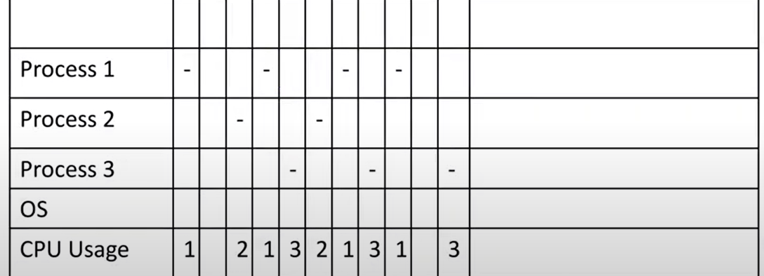

OS

CPU usage is number of process. Who gets the CPU decided by the OS.

This image doesn’t explicitly show that when you switch from process 2 to process 1, OS does the switching.

Sometimes CPU stays idle. You keep very large CPU percentage idle to get quick response and interactivity all the time.

This is not acceptable for mainframe computers. They are very expensive, they say “I am wasting CPU time. I need more data, more process.”. If you don’t have more processes, run another OS and rent it out to some other company.

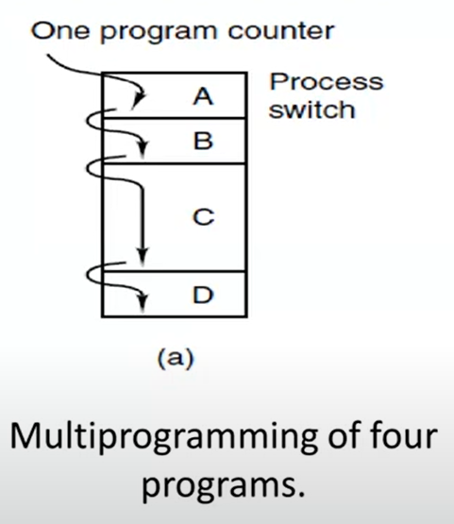The Process Model

A process is just an instance of executing program, including the current values of the program counter, registers, and variables.

Conceptually, each process has its own virtual CPU.

In reality, of course, the real CPU switches back and forth from process to process, but to understand the system, it is much easier to think about a collection of processes running in (pseudo) parallel than to try to keep track of how the CPU switches from program to program.

You need help of hardware (interrupts) for multiprogramming. That’s why they didn’t have multiprogramming in early PCs (ALTAIR 8800).

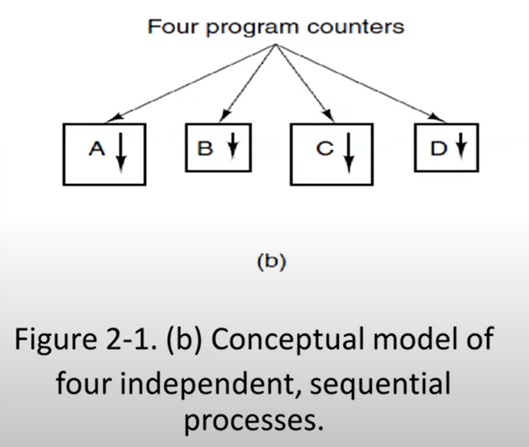In this chapter, we will assume there is only one CPU. Increasingly, however, that assumption is not true, since new chips are often multicore, with 2, 4, or more cores.

Process Creation

4 principal events that cause process to be created:

1. System initialization: Processes that stay in the background to handle some activity such as email, Web pages, news, printing, and so on are called **daemons**.
   1. At system initialization, your system makes lots of daemons.
   2. Daemons sleep most of the time, wait for a task from OS.
2. Execution of a process creation system call by a running process.
   1. fork()
   2. CreateProcess()
3. A user request to create a new process.
4. Inititaion of a batch job.
   1. For mainframes

First 2 are our interest.

In UNIX, there is only 1 system call to create a new process: **fork**

Usually, the child process then executes execve or a similar system call to change its memory image

When a user types a command, say, sort, to the shell, the shell forks off a child process and the child executes sort.

In Windows a single Win32 function call, **CreateProcess**, handles both process creation and loading the correct program into the new process.

Win32 has about 100 other API functions, procedure calls, for managing and synchronizing processes and related topics. For Linux it is at most 5 or 10.

Process Termination

Typical conditions which terminate a process:

1. Normal exit (voluntary): **exit** in UNIX and **ExitProcess** in Windows. Process ask to OS to terminate it. OS says “I am gonna kill you, take away the memory that you are using, and I will never schedule you. I will also update my page tables so that you don’t have any entry in it.”.
2. Error exit (voluntary): Process makes the thing but there is a problem. Almost same as first one.
3. Fatal error (involuntary): Executing an illegal instruction, referencing nonexistent memory, or dividing by zero
   1. For example a regular program tries to execute a privileged instruction. For example it says, “I am gonna read port number 330, into register number 1 (IN 330, R1).”. It is trying to do I/O. If you are not in the kernel mode, this instruction will trapped to the OS. OS, depending on the configuration, may decide to terminate that program.
4. Killed by another process (involuntary): In UNIX this call is **kill**. The Win32 function is **TerminateProcess**. The killer must have the necessary authorization to do in the killee. If I am parent process, I can kill my child processes.

You, as a user, kill a process in task manager because you created them. That’s GUI process that’s killing another process.

Process Hierarchies

In some systems, when a process creates another process, the parent process and child process continue to be associated in certain ways.

In UNIX, a process and all of its children together form a process group. A special process, called **init**, is present in the boot image.

* init holds all the processes.
* If you kill init process, it is gonna shutdown the all computer bc everything is child of init process

Windows has no concept of a process hierarchy. All processes are equal.

Process States

***cat chapter1 chapter2 chapter3 | grep tree***

Depending on the relative speeds of the two processes it may happen that grep is ready to run, but there is no input waiting for it.

It must then block until some input is available.

3 states a process may be in:

* Running (actually using the CPU at that instant)
* Ready (runnable; temporarily stopped to let another process run)
* Blocked (unable to run until some external event happens)
  + daemons are blocked most of the time

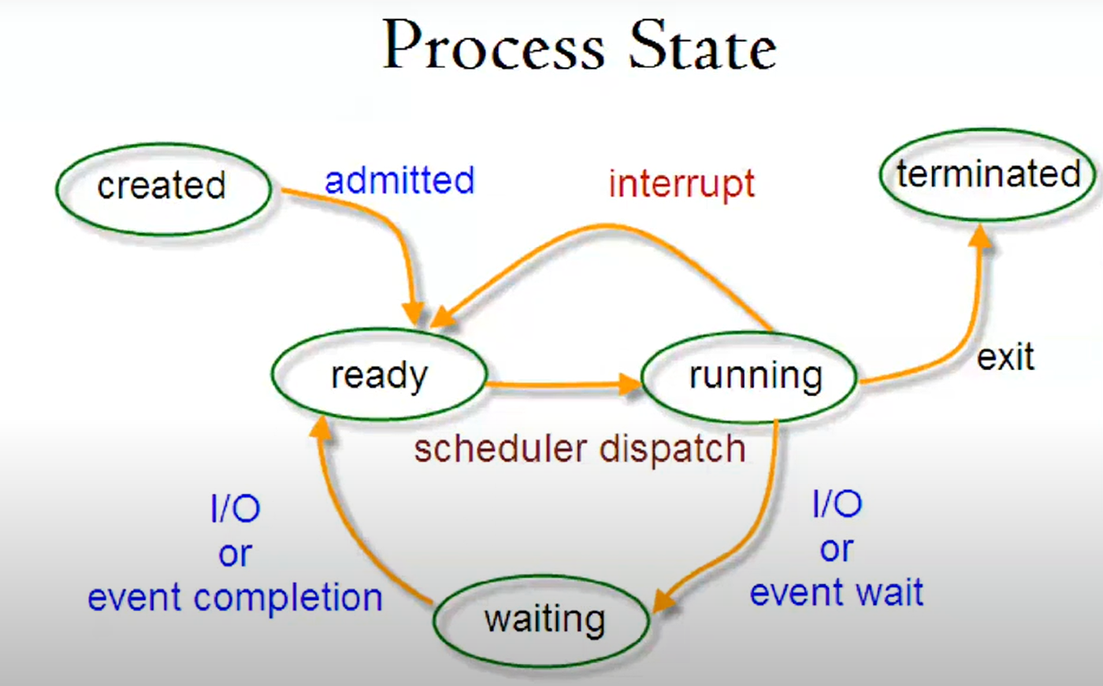

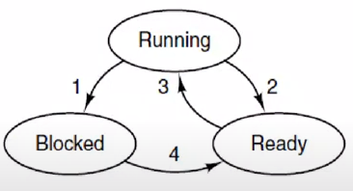

1. Process blocks for input

2. Scheduler picks another process

3. Scheduler picks this process

4. Input becomes available

A process can be in running, blocked, or ready state. Transitions between these states are as shown.

In ready part, process is actually in ready queue. There might be several processes. They are waiting for their turn for the CPU.

It is task of OS to pick a process from a ready queue and let it execute. This is scheduling.

If an interrupt happens (for example, your disk said your data is ready), transitions 2 happens.

A process is running and it needs help from OS either reading data from I/O units or sending some data to the I/O ports, etc. Then transition 1 happens. Blocked is also a queue. There might be several processes waiting for data.

Usually all daemons are blocked. They are waiting for sth to happen. If they would be ready, their CPU utilization wouldn’t be 0, from time to time they run.

|  |  |
| --- | --- |
| **TRANSITION NUMBER** | **CAUSE** |
| 1 | process itself |
| 2 | hardware interrupts |
| 3 | OS/scheduler |
| 4 | OS |

There is no direct transition from,

* blocked to running (there might be some other process in ready queue waiting for scheduling)
* ready to blocked (If a process is not executing, it cannot ask OS to do sth)

Scheduler is also a process. Sometimes it is running, sometimes it is ready, sometimes it is blocked. You hopefully think that it is always either running or ready. When it is ready, it has to be at top of the process priorities because if it is not, then it cannot schedule.

Scheduler cannot schedule itself to be scheduled. It doesn’t say I am gonna run myself now.

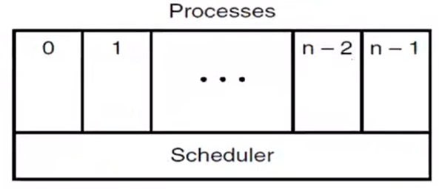

*The lowest layer of a process-structured OS handles interrupts and scheduling.*

*Above that layer are sequential processes.*

Here the **lowest level** of the OS is the scheduler, with a variety of processes on top of it.

All the interrupt handling and details of actually starting and stopping processes are hidden away in what is here called the scheduler, which is actually not much code.

Scheduler is mostly written in **assembly** code. All it does is make a decision which process to run next. So I need to pick a process from the ready queue and let it run.

Decision to choose from ready queue is not complicated most of the time. It is first come first served approach most of the time.

Implementation of Processes

A table (an array of structures), called the process table, with one entry per process.

Process table is kept in kernel space.

This entry contains important information about the process’ state (all for running, ready, blocked processes), including its

* program counter,
* stack pointer,
* memory allocation,
* the status of its open files,
* its accounting (scheduling based on how much CPU I had use, informations about the process at task manager) and scheduling information, and
* everything else about the process that must be saved when the process is switched from running to ready or blocked state so that it can be restarted later as if it had never been stopped.

If program is blocked or ready, I have to keep its registers.

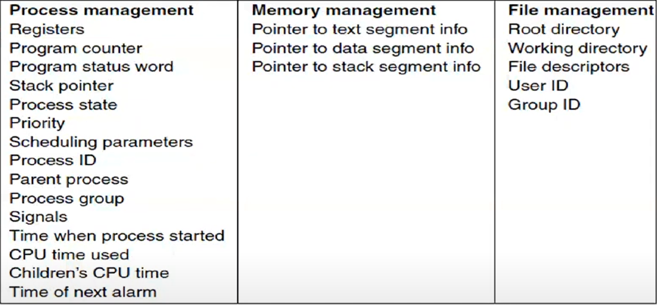

*Some of the fields of a typical process table entry*

When interrupt happens (transitions number 2 and 4):

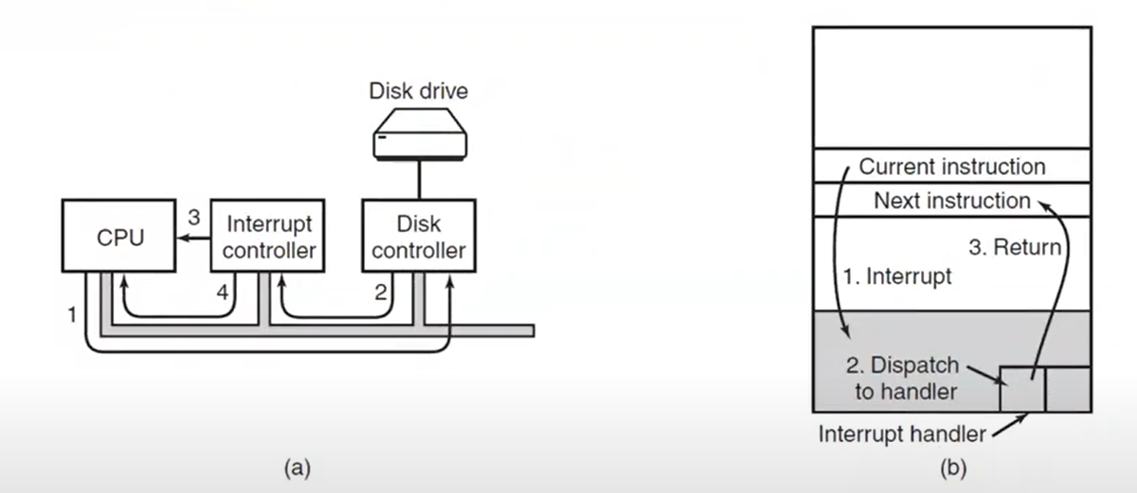

kernel space

(a) 🡪 The steps in starting an I/O device and getting an interrupt.

* 3: interrupting the CPU
* 4: information available
  + This information is used to dispatch interrupt handling routine

(b) 🡪 Interrupt processing involves taking the interrupt, reunning the interrupt handler, and returning to the user program.

* Interrupt handler will pick right interrupt handling function according to interrupt type.
* After handling, when data is ready, as a interrupt handler, I might say that if data is ready maybe one of the processes waiting for data is now ready to run. So I will move that process from blocked queue to ready queue.

We might return back to next instruction of original interrupted process or newly ready process.

Interrupt controller is the one who stops the CPU when an interrupt happens. It saves all the information to stack.

Suppose that a user process is running when a disk interrupt happens.

1. Hardware stacks program counter, program status word etc. (not all registers, why? because maybe you don’t need them, rest will be done by OS)
   1. Hardware automatically puts the program counter, etc. in user stack.
2. Hardware loads new program counter from interrupt vector. **That is all the hardware does.**
3. Assembly-language procedure saves registers. All interrupts start by saving the registers, often in the process table entry for the current process. The temporary values are saved.
4. Assembly-language procedure sets up new stack in kernel space (I saved all the data to user stack. It is not my stack.). Saving the registers and setting the stack pointer cannot even be expressed in C! I have to do this in Assembly.
5. C interrupt service runs (typically reads and buffers input).
6. Scheduler (usually written in C) decides which process is to run next.
   1. Maybe one or more than one blocked process become a ready process.
7. C procedure returns to the assembly code.
8. Control is passed back to the assembly-language code to load up the registers and memory map for the now-current process and start it running.

***SKELETON OF WHAT THE LOWEST LEVEL OF THE OS DOES WHEN AN INTERRUPT OCCURS.***

There is no way to modify registers in C. That’s why we use assembly.

You have to use assembly when saving CPU registers to process table and during scheduling (put all the data at process table back to CPU).

Modeling Multiprogramming

As long as there is a process available in ready queue, my CPU will be 100% occupied.

If I have 1 process running, no process ready, many processes in blocked queue, that means I will be wasting CPU time.

* We say p% of the time my process is blocked and it is waiting for sth to happen.
* Lets say p is 20.
* If I have a single process, I can keep my processor busy only (100-p)% of the time. I am using my CPU (80)% of time.
* In order to increase process utilization ratio, I can add one more process.
  + Lets say I am running 2 processes. Each of them is blocked in 20% of the time.
  + If first process is busy 20% of the time, and other process is busy 20% of the time,
    - probability that both of them are busy at the same time is 0.2 * 0.2 = 0.04
    - 1 – 0.04 = 0.96 ---> 96%
    - So by adding another process, I am 96% efficient in terms of CPU usage time.
    - This assumes higher the CPU efficiency, better my OS bc I am doing, for example, batch processing OS, not interactive OS.
    - With interactive OS, you want your CPU to be free most of the time.

Suppose that a process spends a fraction p of its time waiting for I/O to complete.

With n processes in memory at once, the probability that all n processes are waiting for I/O (in which case the CPU will be idle) is pn.

CPU utilization = 1 – pn

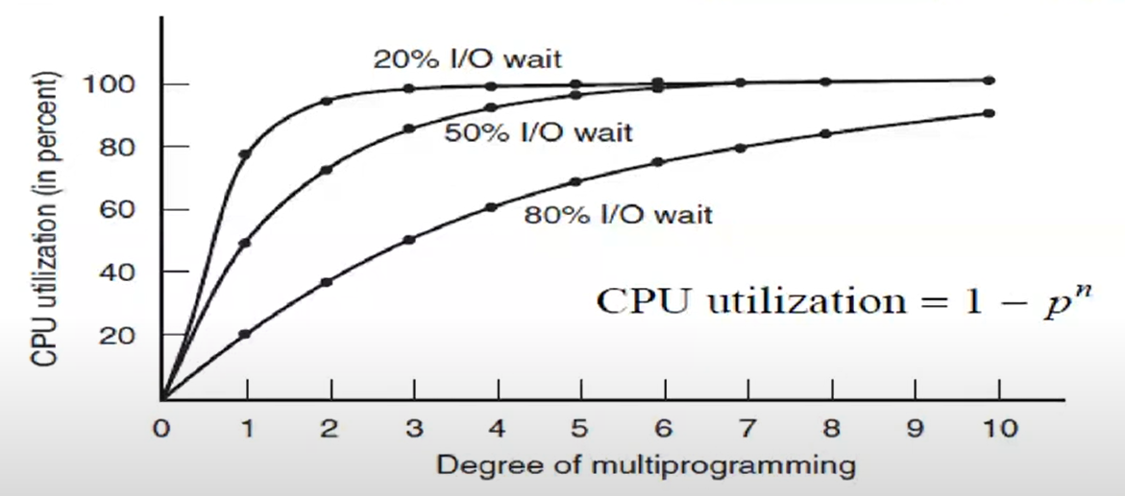

p value is 80.

*CPU utilization as a function of the number of processes in memory*

Below curve process example:

* Word, Excel, any kind of editor – it waits for keystroke or mouse movement. It uses the CPU small amount of time.
* I can keep CPU 20% busy if 1 process is running.
* For modern personal computers, most processes are like this.

Above curve process example:

* Compiler. Once it loads everything in the memory, it doesn’t need any data. It keeps processing that data until the compilation is completed. You can think libraries are in the disk, I need I/O, that’s true but suppose everything is on memory and I am compiling them.
* Process for deep learning optimization.
* Algorithm trying to find all the digits of PI.
* 80% of the time, I can keep running. Process keeps my CPU busy 80% of the time.
* If I have most of these processes, my PC will be unresponsive.

if processes spend 80% of their time waiting for I/O, at least 10 processes must be in memory at once to get the CPU waste below 10%.

Media player stops with timer interrupt. It reads the data, it shows its frame on the screen and it goes to sleep. It is waiting for its time to come. It is in blocked queue. It asked to OS wake me up when the time is ready. It is waiting for timer interrupt. Most of the time media player is idle. It is not keeping the CPU busy. When interrupt happens, it immediately reads the data from the disk or somewhere else or maybe data is ready in memory, it shows it on the screen and goes to sleep again. CPU is fast enough to handle this process in a very efficient way.

Most of the time, video games are busy with doing I/O. Most of the time they keep putting data to graphics cards, graphics controllers memory. Your computer system is busy but CPU is not busy that much.

Sometimes people make graphic cards so smart. Instead of moving data between graphics card controller and the main memory, they keep most of the data on the graphic card’s memory. Graphic cards have their own CPUs. Sometimes many CPUs which we call them GPUs. So graphic cards become another kind of computer and I communicate with that computer from my CPU. My CPU is not that busy. My graphic card is busy. Same thing is going on with playing a video. So your CPU is not busy doesn’t mean that your computer is idle. It is either doing I/O, or your harddrive is working hard, or your graphic card is working hard or other controllers are working hard.

A computer has 8 GB of memory

OS takes up 2 GB and each user program takes 2 GB

3 programs in memory at once

With an 80% average I/O wait, we have a CPU utilization (ignoring OS overhead) of 1-(0.8)3 or about 49%

* 80% of the time processes wait for I/O ---> p = 0.8
* look below curve in the graph, with 3 processes CPU utilization is about 49%

I want to increase my CPU utilization, my CPU is expensive, lets say this is not interactive computer but process server.

* I cannot change my process to become like 50% wait time. It is not written that way.
* I cannot put more processes bc I don’t have memory.

Adding another 8 GB of memory allows 7-way multiprogramming, thus raising the CPU utilization to 79%

* p is same (0.8)
* There will be 7 processes 🡪 1-(0.8)3 = 0.79 🡪 CPU utilization is around 79%
* by increasing the memory, I am getting better CPU utilization

In other words, the additional 8 GB will raise the throughput by 30%.

More than 16 GB of memory, it is not gonna increase my CPU utilization much.

Threads

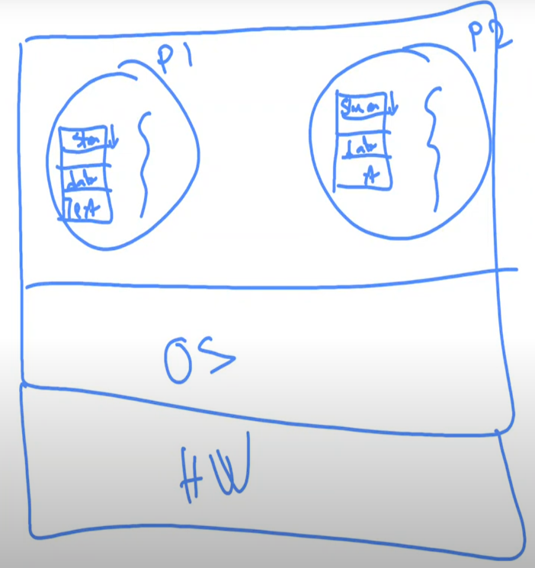 🡪 execution, it is like thread  
  
Address spaces of process 1 and process 2 are completely different. There is no way I can access P2’s space from P1. They are scheduled by OS.



Why don’t I execute 2 things at the same time in the same process? 2 executions, 2 functions are running in parallel seemingly but they are sharing the same process’ address space. You can have more than one thread running inside the same process. Even though I have a single CPU, my OS might help me in a way that 2 threads in P1 are running in parallel at the same time. Nice thing is, these threads are sharing the same memory, same address space as their process.

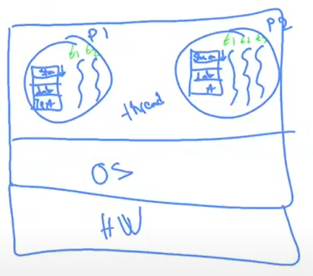

This idea will not make our process ID obsolete, we need it. They are basic abstraction method of CPU employment.

Thread is part of a process. You may call thread as execution part of a process. I can have more than one execution thread in the same process.

In the process you should have at least 1 execution thread.

P1’s threads cannot access any part of P2.

Like processes: programs in parallel

Unlike processes

* Share the same address space and data of a single process
* Lighter and faster for use (10 to 100 times faster to create)
  + They are very fast in terms of writing parallel programs
  + Making a new process is more expensive bc threads share the same process table, I don’t need to create new process table. Also they share memory. I don’t need to copy anything if I want to create another thread in P1. I don’t need to copy memory at all.
  + When you make a new process out of P1, then you need to make copy of P1.
  + Lighter means they don’t need much CPU time, and memory.
  + Faster means, bc of context switch advantages, when you switch from one thread to another thread in the same process, you don’t change your address space. So it is much faster.
* Threads yield no performance gain when all of them are CPU bound
  + If all the threads are CPU bound, they are trying to use the CPU all the time, then maybe you shouldn’t use multithreaded applications
* There is no protection between threads
* Threads co-operate, they do not compete
  + Multiprocess programs compete. For example, Excel and Word compete to get more CPU resources, more memory resources bc they have different task to run. They are different processes. They are trying to achieve different things.
  + Threads in same process try to help each other. Since they co-operate, I don’t put protection between them. They need to read each other’s data and produce data for the other.
  + Threads run in synchronization.

The main reason for having threads is that in many applications, multiple activities are going on at once

Some of these may block from time to time

By decomposing such an application into multiple sequential threads that run in quasi-parallel, the programming model becomes simpler.

Threads look like they run in parallel even though we have a single CPU. There is always switching going on between those threads which is done by the scheduler of the threads.

Thread Usage – 1

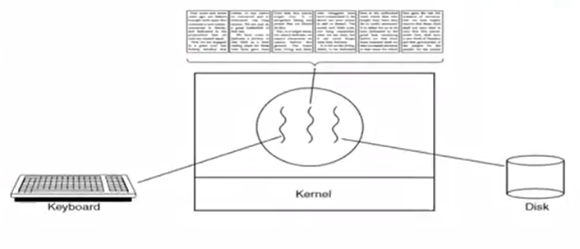

*A word processor with 3 threads*

get input – screen update – take backups 🡪 If I write them differently, it will be easier to design and implement them and test them.

1 thread interacts with the user

The other handles reformatting in the background

The 3rd thread can handle the disk backups without interfering with other two

While one of the thread is busy, others will stay silent.

Sometimes I say that taking backups is second priority. If I need to update the screen or if I need to handle the keyboard input, I don’t take backups, it can wait. So backups will be taken only when two others are not running.

This is not easy to write with multiprocess architecture (you need lots of OS help) bc they all need to share the same data which is data of the document (blue rectangle – backup reads and writes to disk, other reads and update the screen, keyboard modifies it).

You can have single thread just like this:

while (true){

handle_keyboard();

update_screen();

take_backup();

}

Suppose I am taking the backup and ask OS to write 2 GB of data to disk. This is very slow. So whole process will be blocked by OS until disk is done writing the data. I am losing interactivity. CPU is idle while data is written to disk. I am also wasting CPU time.

With multithread way, while one thread is blocked other 2 threads can continue execution.

Thread Usage – 2

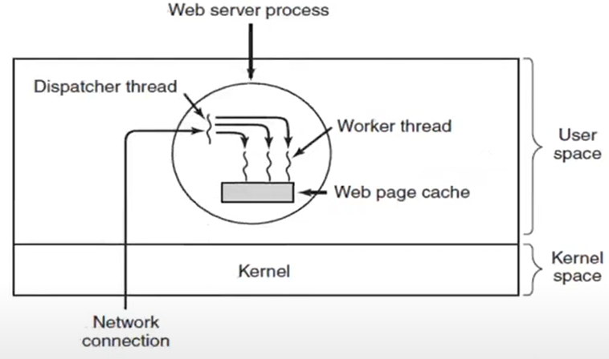



*A multithreaded Web server*

Here one thread, the dispatcher, reads incoming requests for work from the network and dispatch one of the three worker threads (real servers). If thread 2 is blocked, would you schedule 3, 4 or 1?

* 3 and 4 are equally important but 1 is different. Without 1, whole system falls down. Requests should be handled immediately. 2-1-3-1-4-1…
* If I do this with kernel-level thread library; 1,2,3,4 are all same.
* If I do it in user level, bc I am writing my own thread scheduling algorithm, I say 1 is more important than others.

After examining the request, it chooses an idle (i.e., blocked) worker thread and hands it the request, possibly by writing a pointer to the message into a special word associated with each thread.

The dispatcher then wakes up the sleeping worker, moving it from blocked state to ready state.

Dispatcher thread:

while(TRUE){

get_next_request(&buf);

handoff_work(&buf);

}

--------------------------------------------------------------------------------------------------------------------------------

* It gets next request from the web.
* Then all I do is, I have a pool of threads that are blocked and waiting. I choose one of them and hand over the work.

Worker threads do this:

while(TRUE){

wait_for_work(&buf);

look_for_page_in_cache(&buf, &page);

if (page_not_in_cache(&page))

read_page_from_disk(&buf, &page);

return_page(&page);

}

--------------------------------------------------------------------------------------------------------------------------------

* Most of the time these threads are blocked in wait_for_work part. As soon as dispatcher thread handoff, they get to work.
* I might be blocked in read_page_from_disk part bc I am gonna read sth from disk.

If I put all of them in the same thread, either you are gonna be very slow. You can handle only 1 request at a time even though your CPU is available. Also your code would be very complicated bc you will handle both dispatching and handling many request at the same time.

All threads share web page data (web page cache). More than one request may ask for same data. I need to share the same data between threads so that I can provide the data. So I have multithread instead of multiprocess.

Dispatcher should have highest priority in terms of scheduling. If the thread scheduler knows the dispatcher thread, it would give the dispatcher thread the highest priority. If dispatcher is ready, it should run definitely.

If sth happens to dispatcher thread, all web server is done. If it dies, you should make new dispatcher thread immediately. Maybe there should be one other thread always trying to see if the dispatcher thread is running. If not, it makes a new one immediately.

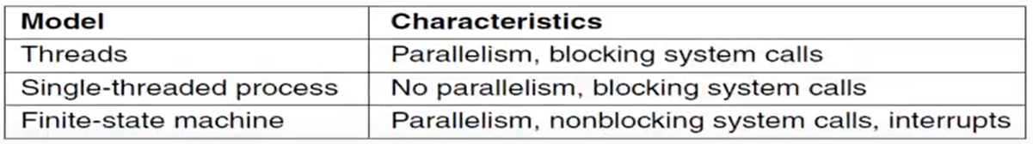

*Three ways to construct a server*

The Classical Thread Model

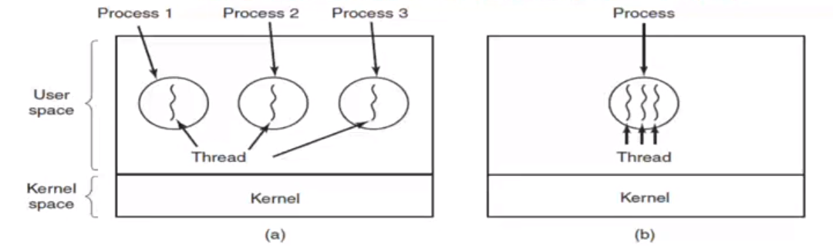

*(a) 3 proesses each with 1 thread*

*(b) 1 process with 3 threads*

The process model is based on 2 independent concepts: **resource grouping and execution**. We can separate them!

Because threads have some of the properties of processes, they are sometimes called lightweight processes.

There is no protection between threads because it is impossible (they are in same process, there is only 1 address space) and it shouldn’t be necessary (if you want protection, don’t use multithreading)

All the threads can share the same set of open files, child processes, alarms, and signals, and so on.

If one thread opens a file, that file is visible to the other threads in the process and they can read and write it.

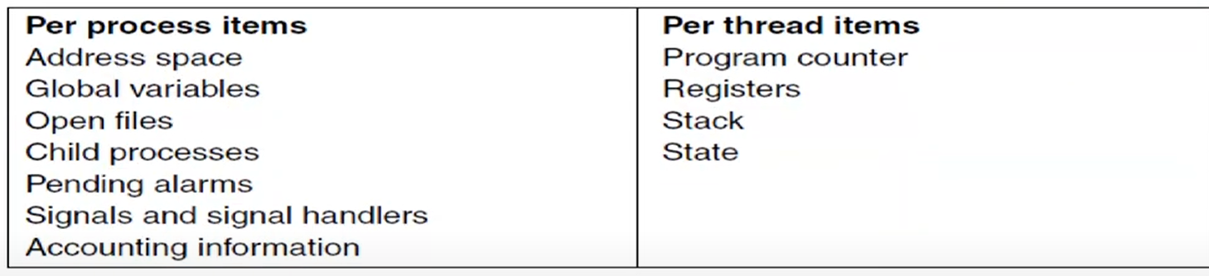

*The first column lists some items shared by all threads in a process.*

*The second one lists some items private to each thread.*

If I don’t have my program counter and registers, then I cannot be an execution.

State for a thread 🡪 running/ready/blocked

Two threads can run the same function, since they have their own stack, they can run that function without any problems.

This would be problem:

int gi = 10;

void f(int k){

double d = 1.0;

char *c = new char[100];

gi += 2;



}

because all threads running this function f are updating the same global integer. I will lose track of gi. I don’t know who updated gi and when. Global integers are in the heap and heap is shared. This is race condition 🡪 You don’t know what kind of output you are gonna get from this function. Suppose you are running 3 “f”s in 3 different threads. You don’t know which one is incrementing gi first because thread scheduling is not decided by you. You need to tell to OS or thread scheduler that “I am gonna update global position, I am doing sth critical. I need access rights. I am telling you that I am entering this critical location (red), while I am in critical region, don’t let anybody enter the critical region.” So only you should be allowed to do that.

It is OK to have constant global variables.

char array is also on heap but I keep pointer c in my special stack as a thread so it is not a problem.

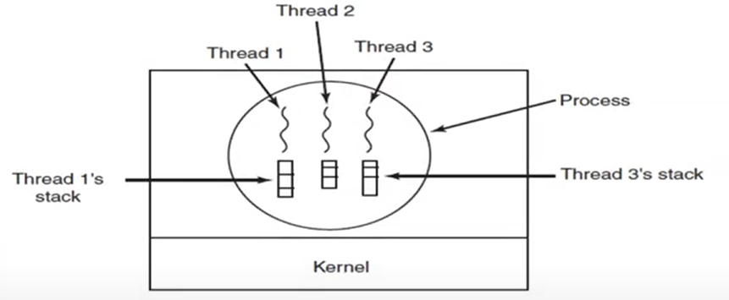

*Each thread has its own stack*

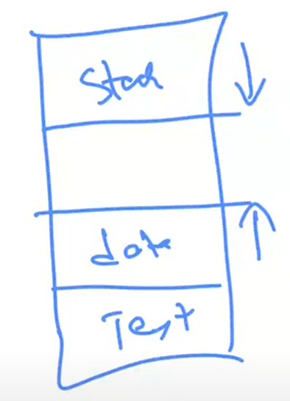This is general UNIX type of process memory configuration.

Stack are is divided into threads stack space. You are using process’ stack for all the threads.



There is no separate process stack anymore. Even if you don’t use threads for a process, there has to at least one thread (thread means execution). In that case there is only single stack and that thread is using that stack.

Global variables are stored in data (heap).

POSIX Threads

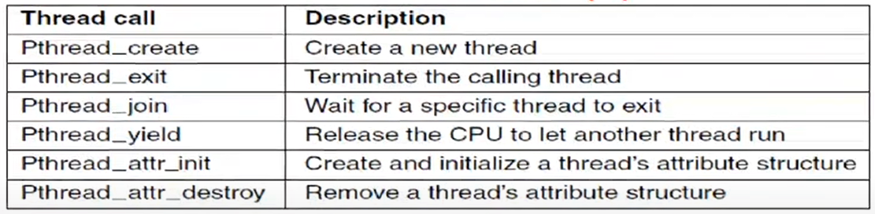

*Some of the Pthreads function calls.*

With create_thread, it is not necessary (or even possible) to specify anything about the new thread’s address space

thread_yield is important because there is no clock interrupt to actually enforce multiprogramming with the threads as there is with processes. For some thread libraries there is.

* Threads don’t have clock interrupts (interrupting the threads). Threads voluntarily release their CPU. But of course, whenever a thread is blocked, for example when it needs some data from secondary storage it asks to OS and it is blocked. In this case thread scheduler can schedule another thread. Other than that, there is no clock interrupt to enforce multiprogramming.
* I have create, exit, waitpid (for join) for process but don’t have yield.
* You are saying that “Even though I can continue, I need the CPU, but I know that I am co-operating with other threads in the same process. I am gonna let the CPU go. I am telling to thread scheduler that ‘I am letting the CPU go, use the CPU for other threads.’ bc we need to be in cooperation so that whole application runs in harmony.”
* Processes don’t think about other processes.

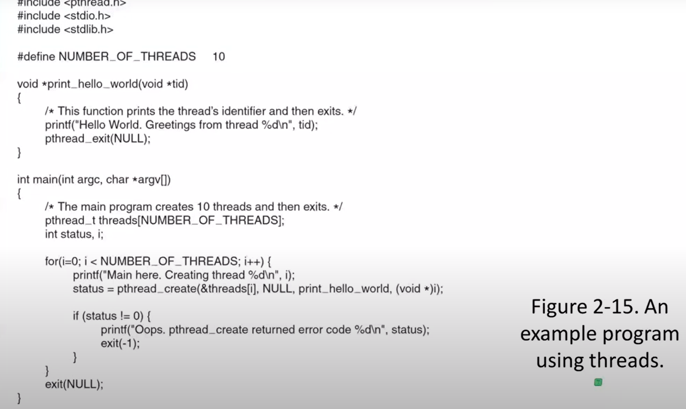



print_hello_world is my function pointer.  
(void*)i is the parameter you passed to that function. I type casted i.  
As soon as you execute this line, your thread is created and it starts running.

When void pointers are involved, C compiler turns of type checking. tid doesn’t have to be integer.

You never guess which thread will print first. Scheduling is not decided by you. It is so complicated to guess the order of the execution. It depends many many things. It looks like random (Of course there is nothing random in computers.).

If you have application that depends on order of execution of threads then you need to do some inter-process communication.

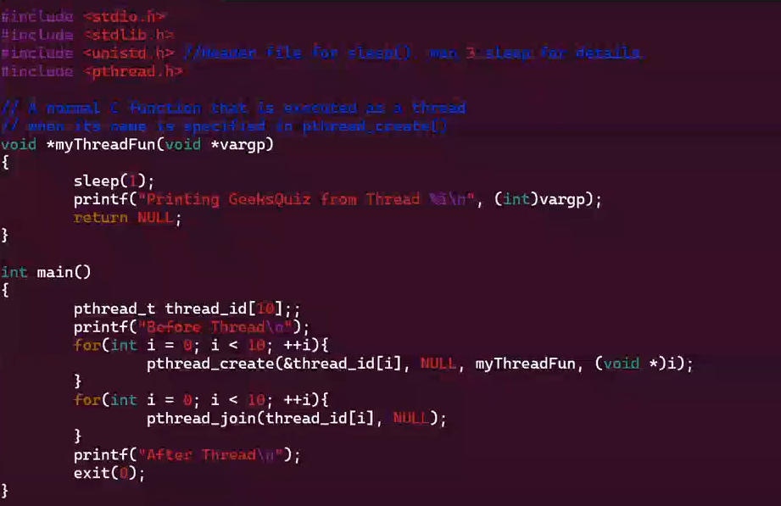

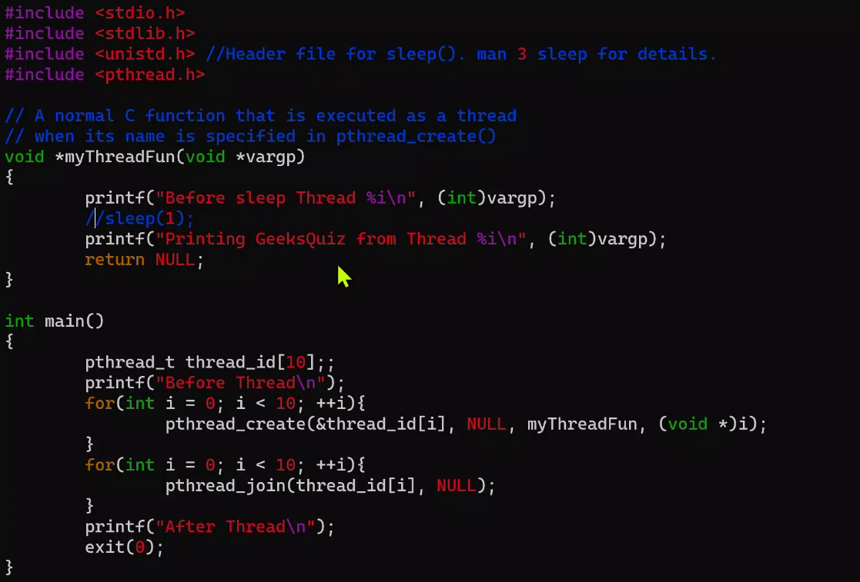

Each thread, as soon as they start running, they sleep and prints the message and then terminate. We don’t sleep total of 10 times. Threads are sleeping in parallel. So it is gonna take 1 second.

Each time you run same program, without compiling it again and again, you get different order of threads.

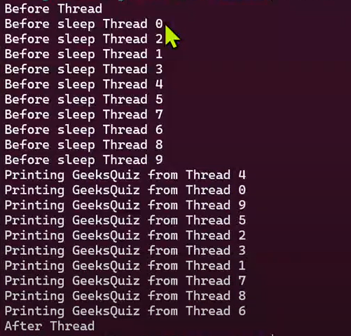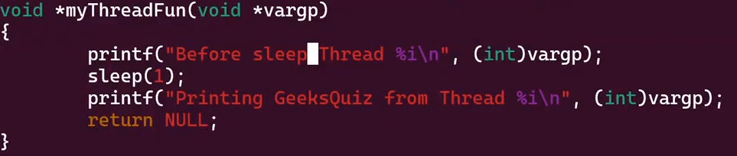

You get this with above modification. Who is gonna wake up from sleep first, we don’t know. It depends on scheduler decision.

Most of the time I get a different result because I didn’t do any synchronization between the processes. There was a race condition bc I am dependent on what the scheduler decides.

Implementing Threads

3 basic strategies:

* User-level: possible on most operating systems, even ancient ones
* Kernel-level: looks almost like a process (i.e., Linux, Solaris)
* Scheduler activations (Digital Tru Unix 64, NetBSD, some Mach)

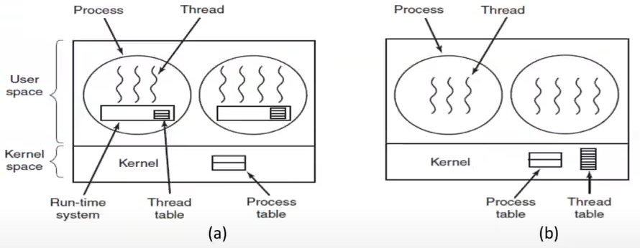

*(a) A user-level threads package*

*(b) A threads package managed by the kernel*

Implementing Threads in User Space

In user space, you do all of your scheduling yourself without telling to OS. All the thread library is in user space. When you make a new thread, process makes a new thread. When you do the scheduling the process itself does the scheduling.

Kernel doesn’t know that there is more than one thread inside the process. Kernel thinks that there is a single process and single thread running.

You don’t need OS support for user space threads. Doesn’t matter if your OS supports multithreading or not, it will work on any kind of OS. Second advantage is, when you switch from one thread to other one, there is no OS involved so there is no context switching at all. Yielding the CPU is not a system call. Thread scheduler immediately switches from one thread to another one. You don’t have to invalidate your cache or anything like that.

Also, if you implement your threads in user space, then scheduling algorithm for specialized applications like the web servers would be possible. When I do thread scheduling, I treat dispatcher differently. I say that has the highest priority. Kernel wouldn’t know about that thread. If I am doing scheduling in kernel, for kernel all are threads. All you can do is maybe increasing the priority of one of them. I like to do more than that bc I know the structure of my multithreaded application and I want to write my own thread scheduler for this kind of application without using kernel’s thread scheduler.

Other approach is OS knows about your threads. To make a new thread or terminate a thread or yield a thread, you have to make a system call to OS.

When thread is yielding the CPU, it tells to OS. You have to make system call means that you have to change CPU mode from user mode to kernel mode. It is expensive. It is not as expensive as switching from one process to another because address space stays the same. No cache invalidation, etc.

User-Level Threads

Thread creation, destruction, and scheduling done at user level by libraries

To create a thread, must allocate storage for stack, program counter, registers, state, etc. in a thread table in user space

When a thread yields the CPU or blocks, the thread library saves everything in the thread table

The thread scheduler which runs in user space finds the highest-priority thread that’s ready to run

Its registers, program counter, etc. are restored from its thread table

***Efficiency gains:***

* No system calls needed
* No context switch
* No copying data safely across a protection boundary
* No need to flush the hardware memory cache

***Other advantages:***

* Allows each process to have its own customized scheduling algorithm
  + E.g., garbage collector thread
* Scales better than kernel-level threads
  + I can have as many threads as I like as long as my memory is enough
  + Kernel-level threads may require table & stack space in the kernel-level
    - problematic if when large number of threads

***Disadvantages:***

* Blocking system calls
  + Remember word processor with 3 threads. Assume backup thread is running and it needs to write some data to disk so it asks to OS to write some data.
  + OS says “I am gonna block you bc it will take some time.”. OS doesn’t know there are 3 threads running in the same process. OS thinks there is only single process running.
  + So OS blocks the whole process including the thread scheduler.
  + Whole purpose of having multithreaded application is to continue doing screen refreshing and keyboard handling at the same time while the system is busy writing the data. In this case my whole applications is blocked and I don’t get any advantages of having a multithreaded application.
  + ---------------------------------------------------------------------------------------------------------------------
  + What happens if a thread issues, say, a read() call and there’s no data available?
  + The kernel will make the whole process block bc it’s unaware of the thread structure
  + This is contrary to the purpose of having threads
    - Difficult issue in user level threads 🡪 need moficiations to OS, e.g. making all system calls to be nonblocking
* Page faults
  + If one of the threads is not happy about the memory it uses, if memory is not sufficient, then OS needs to get more memory but while it is doing that, it is gonna block the whole process.
  + ---------------------------------------------------------------------------------------------------------------------
  + Part of the virtual memory system; won’t say much now
  + Briefly, though – a trap occurs bc referenced memory isn’t available
  + No ability to suspend just one thread
* Inability to benefit from multiprocessor CPUs
  + If OS doesn’t know there are 3 threads on it, it cannot assign each thread to different CPUs. It will assign only 1 CPU to the process.

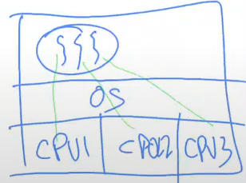

* Kernel cant automatically grow per-thread stacks
  + If I need more stack space for one of my threads, OS doesn’t know about it (all it knows is there is 1 stack space for whole process). I cant get help in terms of growing my stack for each thread.

All the problems cause by OS inability to help you in terms of assigning processors, scheduling other threads while one of them is busy or giving you more resources.

Implementing Threads in Kernel Space

Thread scheduling and process scheduling are tasks of kernel.

Kernel-level Threads

Kernel manages the thread

* To create/destroy a thread, the originating thread makes a kernel call

Similar thread table, but in the kernel

* Often integrated with process table
* Each process should have its own thread table, there is no global 1 thread table

No problem with blocking system calls – ordinary process scheduling does the right thing

* If one of the threads is blocked, then kernel can schedule another one

Handles multi-CPU case easily

But – thread-switching is expensive, since it needs a context switch

* Thread-switching is still better than process switching but it is more expensive than user-level threads

Still cheaper than process switches, since you can use the same virtual memory map.

Kernel-level Threads – Issues

Fork

* What happens to the threads – does the new process have as many threads?
* Depends on what follows the fork…

How about signals

* They are sent to processes, not threads (in many models)
* Solution: let the thread register to receive the signal – when signal comes, it is passed to it…
* What if more than one thread register for the same signal?

Other Schemes

Hybrid: some kernel-level threads, with each kernel-level thread supporting several user-level threads

* User-level threads are multiplexed to the kernel-level threads
* Kernel is aware of only the kernel-level threads and schedules those

Scheduler activations

Pop-up threads

Hybrid Implementations

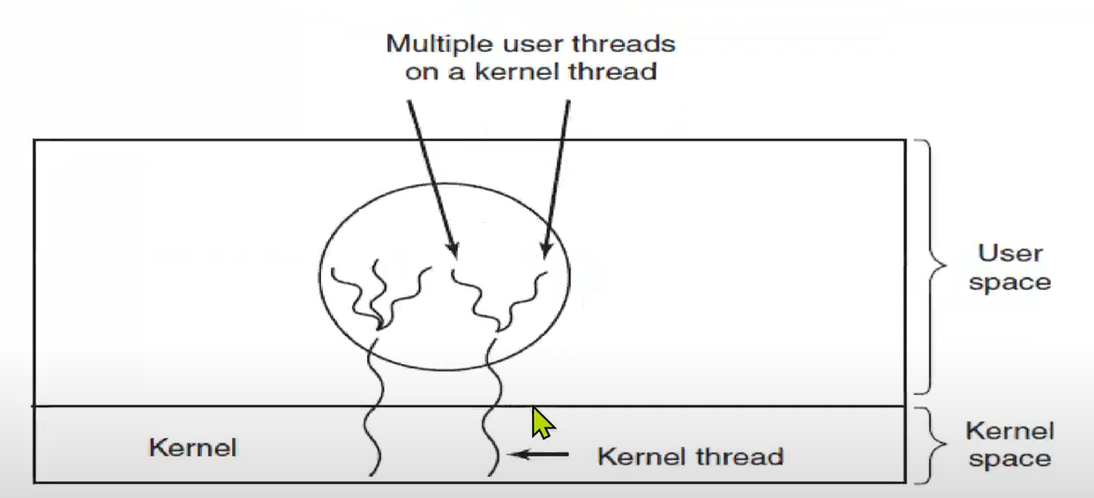



*Multiplexing user-level threads onto kernel-level threads*

There is a thread table in my kernel. Kernel thinks there are 2 threads happening inside the process. In fact one thread is shared by 3 user-level threads, one thread is shared 2 different threads.

You have to have scheduler for the kernel threads and you have to have scheduler for user space. Both of them.

If red thread is blocked, other blue 2 are also blocked. Rest greens can go on bc they are connected to other kernel level thread.

Scheduler Activations

Get the best of both worlds – the efficiency of user-level threads and the non-blocking ability of kernel-level threads

Relies on upcalls

What’s an Upcall?

Normally, user programs call functions (system call) in the kernel

Sometimes, though, the kernel calls a user-level process to report an event

Sometimes considered unclean – violates usual layering

While a process is running, OS says that sth happened. Even though I can continue, OS is telling me that sth is happening and it gives me some information.

While you are running, OS can come to you and give you some information. So your application become more complicated because now you have 2 things:

1. your program
2. your OS information

Scheduler Activations

Thread creation and scheduling is done at user level

* I am gonna take advantage of context switching
* I am not gonna let kernel to schedule the threads for me
* I am not gonna make any system calls

When a system call from a thread blocks, the kernel does an upcall to the thread manager

The thread manager marks that thread as blocked, and starts running another thread

When a kernel interrupt occurs that’s relevant to the thread, another upcall is done to unblock it

Making Single-Threaded Code Multithreaded

Local variables and parameters do not cause any trouble bc they are in stack (each thread has its own stack), but variables that are global (except constant globals) to a thread but not global to the entire program are a problem.

One solution is to prohibit global variables altogether.

Another solution: it is possible to allocate a chunk of memory for the globals and pass it to each procedure in the thread as an extra parameter (each thread have its own global variable)

create global(“bufptr”);

set global(“bufptr”, &buf);

bufptr = read global(“bufptr”);

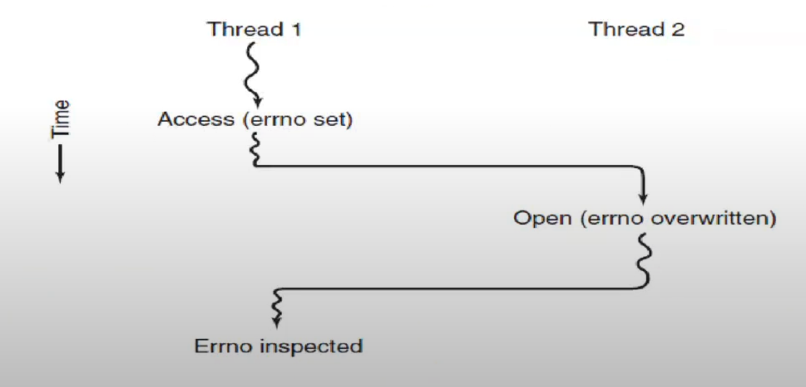

*Conflicts between threads over the use of a global variable.*

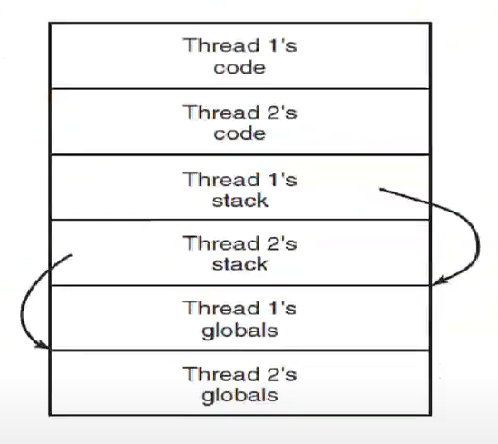

*Threads can have private global variables.*

Using Threads

Library routines may be used by more than one thread simultaneously

Not all routines are prepared for this

Static variables can be overwritten by another thread

Must use reentrant routines

* Reentrant routine is a function that can be called many times by different threads and they are still function properly.

Remember strtok. Each time I call it, it gives me a new token out of that string. Lets say I give “threads are nice” to strtok as parameter at first call. At the second call it gives me word “threads, at third call it gives me word “are, at fourth call it gives me word “nice”. It remembers the original string bc it keeps it in static variable. They are kind of global variables so it is a problem.

Lets say there are 2 threads running strtok at the same time. Their static variables will be interfered with each other. So we don’t like static variables in multithreaded applications.

Write your code always keeping in mind that your code might be using a multi-threaded application. Don’t use static variables and globals.

What is a Reentrant Routine?

A routine that can be invoked more than once simultaneously

Can only use local variables or dynamically allocated variables

Must not use static variables

Many C library routines do use static buffers! So we don’t like them.

NORMAL struct tm *localtime(const time t *timep);

REENTRANT struct tm *localtime_r(const time t *timep, struct tm *result); //result is pointer to   
 output

The normal version stores the result in a static buffer and passes a pointer back;

The reentrant version requires the caller to supply a buffer, there is no internal static data involved.

If I call NORMAL 2 times, one thread will modify the other thread’s data.

What if You Need Global Variables?

Sometimes, there are global variables you have to use

The whole purpose of threads is to share access to certain data

Must synchronize access, but this will come later…

Global variables are a way to communicate between threads. Lets say one thread is producing sth and other one is consuming it. How am I gonna communicate between those? I will write to a global variable and other one reads it. That’s the type of interprocess communication.

Interprocess Communication

Communicate between threads is simple, all you do is defining a global variable. One writes to it, other reads it.

OS gives system call that says share this part of memory between these 2 processes. So it becomes like a global variable.

Interprocess communication is either communication between threads or processes.

Problem is synchronization. One is writing and other is reading at the same time, reading will be corrupted data. It happens 1% of the time. Our computers run so fast so probability of having is very large.

There are 3 issues here:

1. The first: How one process an pass information to another
2. The second has to do with making sure 2 or more processes do not get in each other’s way, for example, 2 processes in an airline reservation system each trying to grab the last seat on a plane for a different customer.
3. The third concerns proper sequencing when dependencies are present: if process A produces data and process B prints them, B has to wait until A has produced some data before starting to print.
   1. Process A should say “I am writing data to shared memory, everybody else wait until I am done.”. Some kind of mutual exclusion has to be supported by the OS.

2nd and 3rd ones apply to threads.

Interprocess communication cannot be done efficiently without the help of OS. OS needs to provide some help.

Race Conditions

Where 2 or more processes are reading or writing some shared data and the final result depends on who runs precisely when, are called race conditions.

If you don’t communicate in a disciplined manner between the processes, you will run into race conditions.

Example spooler.

Printer spooler is a process that stores the printer’s jobs and it prints the jobs whenever the print is ready. It is a daemon actually. It waits for somebody to give them print jobs. Whenever there is a print jobs, it prints it.

Once we write what process wants to print to spooler directory position 7, we increment in from 7 to 8. Problem is, if process A and B want to submit a file at the same time, they both will see in as 7 if the scheduler schedules the process in a way that one of them reads the variable in, before it increment it process switches and process B reads it as 7 again. Now both A and B believe that in is 7. Both of them wrote to same position. Both of them increment value to 8. They think that they are done. One of them didn’t write its file to the right position.

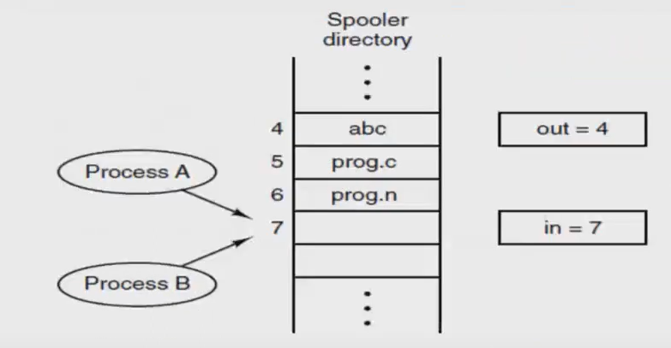

*2 processes want to access shared memory at the same time*

Situations like this, where 2 or more processes are reading or writing some shared data and the final result depends on who runs precisely when, are called race conditions.

What we need is mutual exclusion, that is, some way of making sure that if one process is using a shared variable or file, the other processes will be excluded from doing the same thing.

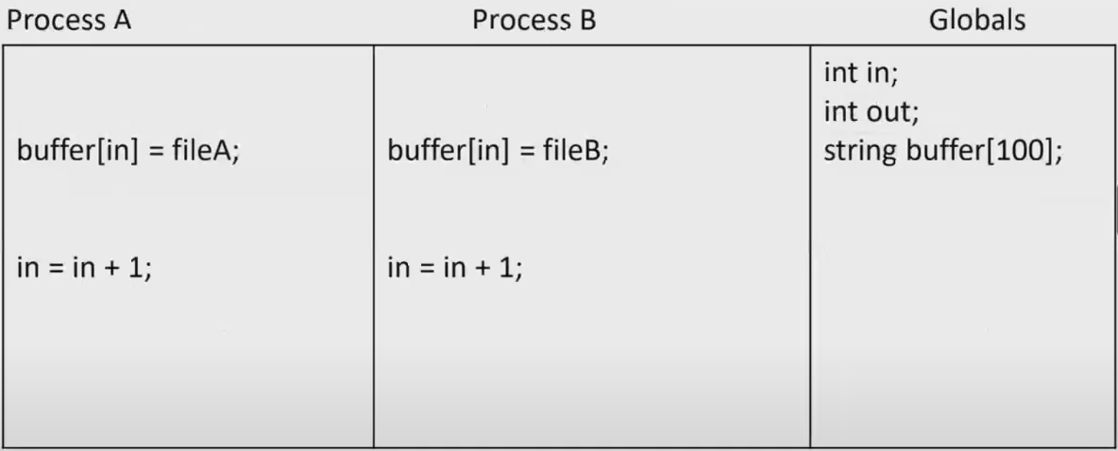

We communicate between processes using our globals.

Process A and B almost execute the same thing but one of them is trying to print file A, other one is trying to print file B.

Lets say process A is running.

* It says buffer[in] = fileA. It executes this line.
* Then switch occurred.
* Process B is gonna do same thing 🡪 buffer[in] = fileB
* Both process wrote to same position.
* Then switch occurred.
* I increment in by 1.
* Then switch occurred.
* I increment in by 1.

Either process A or B’s file got lose bc both of them have written to same position.

You might do something like this:

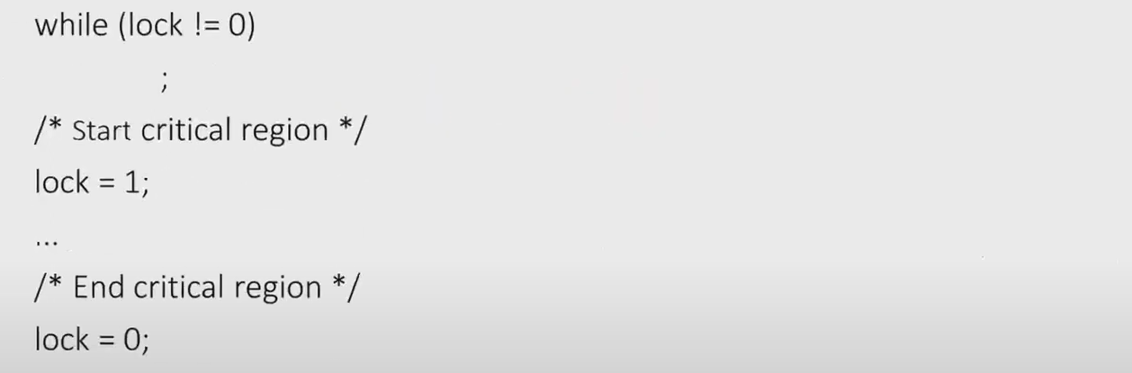lock is my flag, it is global variable. If lock is 0, I can enter my critical region which is writing to the spooler buffers. If lock is 0, then make the lock 1 so that nobody can enter it. I can write my file to buffer and increment value in by 1 at critical region. At the end, I can open the lock by making it 0.

This doesn’t solve the problem always.

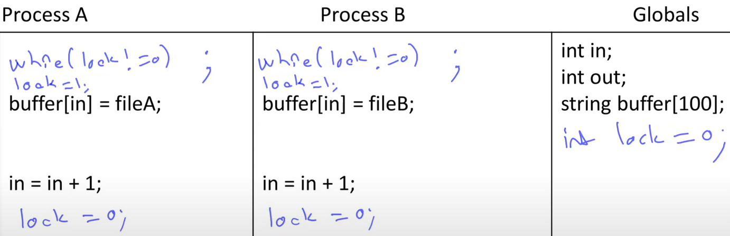

Now I cannot be executing the two buffer[in] at the same time.

Problem here is, if they are running the while loop at the same time, both of them will see lock as 0. So both of them will switch to “lock=1;” line. Both of them will make lock 1. Then they will continue.

So this couldn’t achieve the mutual exclusion.

While I am doing sth critical, I shouldn’t get a switch. There should be a way of telling to OS that I am doing sth critical, don’t switch.

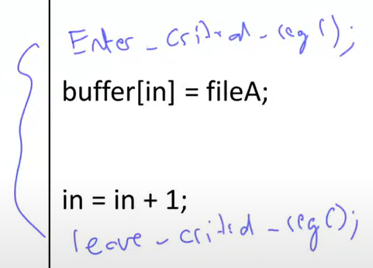Between these critical regions, there should not be switch.

Maybe I should say if I am in critical region, nobody should be in their critical region. So switch can happen but nobody should be entering the critical region. This time, I am not saying there should not be a switch. There could be switch while I am in critical region but when I switch to process B, it cannot enter its critical region.

Critical Regions

MUTUAL EXCLUSION: Some way of making sure that if one process is using a shared variable or file, the other processes will be excluded from doing the same thing.

Part of the program where the shared memory is accessed is called the critical region or critical section.

We should be only 1 in critical region.

Requirements to avoid race conditions:

* No 2 processes may be simultaneously inside their critical regions
* No assumptions may be made about speeds or the number of CPUs
  + You cannot assume “I have only a single CPU and it is so fast. I am not expecting any switches happening. It is only 1 in a million chance that such a switch can happen.”.
  + Switch could happen.
* No process running outside its critical region may block other processes
* No process should have to wait forever (starvation) to enter its critical region
  + Not leaving the critical region forever is not a good thing.

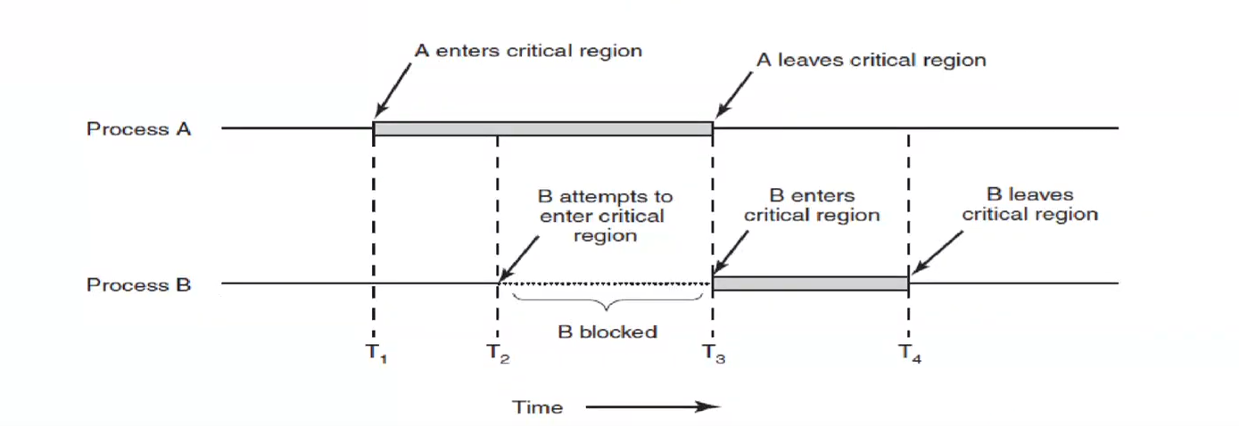

*Mutual exclusion using critical regions*

Mutual Exclusion with Busy Waiting

Busy waiting: Continuously testing a variable until some value appears

It is like “while (lock != 0) ;”. This kind of lock mechanisms are called “spin locks”. I spin the loop until the lock is available.

Proposals for achieving mutual exclusion (achieving synchronization):

* Disabling interrupts
* Lock variables
  + We have seen
* Strict alternation
* Peterson’s solution
* The TSL instruction

Without mutual exclusion, we are gonna run into race issues.

Disabling Interrupts

This requires having the kernel privileges

Available only to the kernel

Better not be available to user processes

Doesn’t work well on multiprocessors

* Other CPUs can produce interrupts and they can change value of lock

A special-case solution for the kernel only

If we disable all the interrupts (including the timer interrupt) no switching can occur.

As a regular user, I cant disable the interrupts.

Lock Variables 🡪 Let’s Use a C Feature: ++

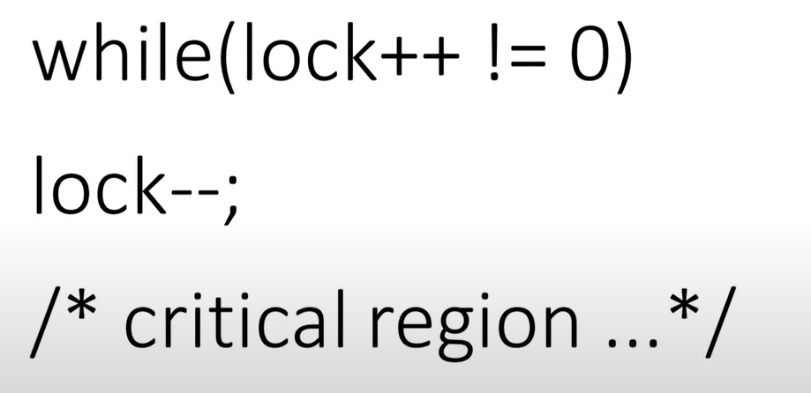

I will run this loop until someone make lock 0.

Is lock++ atomic?

* No – the language makes no guarantees about that

IBM mainframe sequence:

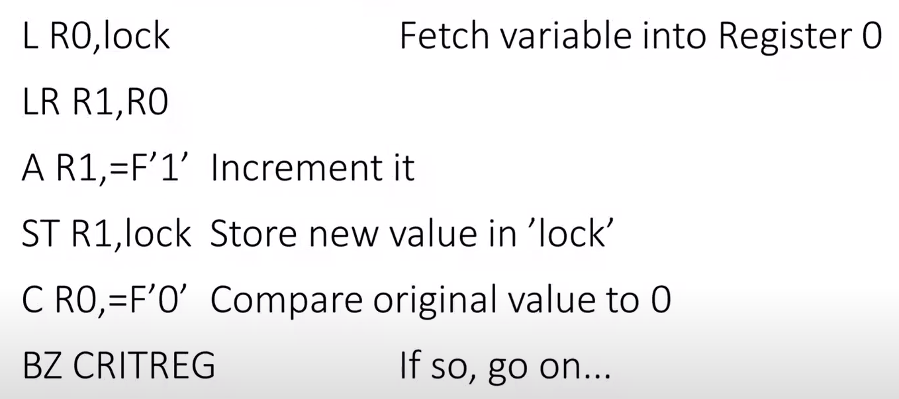

If original value is 0, I can go to the critical region.

make copy of R0 to R1

No atomic increment instruction!

So it looks like the atomic lock++ thing will be executed using 6 instructions. If a switch occurs between any of these instructions, then I am at the same position. I will run into synchronization problems, race issues.

Whenever there is multiple assembly instructions, I will be vulnerable.

Remember this program:



We have created 10 threads and started all of them. We cant get same results every time.

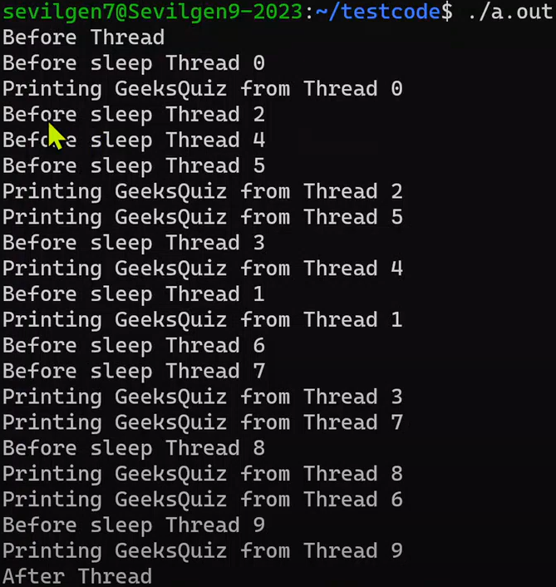Thread 2 starts, switch occurs, thread 4 starts, switch occurs, thread 5 starts, switch occurs, thread 2 completes…



If I want thread running from 0 to 9 in order, there is definitely a race issue with this program.

We need synchronization.

Strict Alternation

Mutual Exclusion with Busy Waiting (Software solution, without getting any help from OS or hardware – like disabling interrupts):

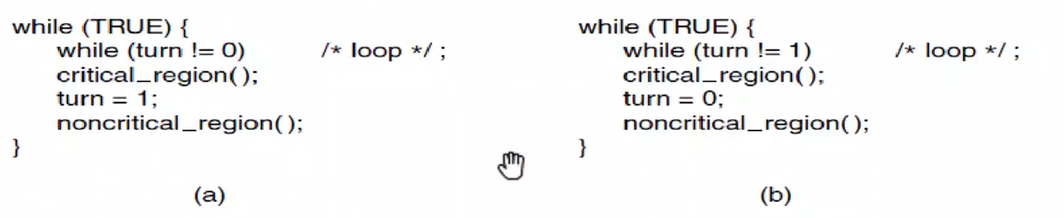



Continuously testing a variable until some value appears is called busy waiting.

A lock that uses busy waiting is called a spin lock.

turn is globally shared variable. If turn is 0, process a loop will not run and I go into critical region. After I am done, I will make turn 1 and I will do some non-critical region stuff.

Process b waits until process a makes turn 1. They cannot be at the critical region at the same time.

Red parts are critical regions.

This is STRICT ALTERNATION.

Remember requirements to avoid race conditions. 1-2-4 are okay but number 3 is problem which is:

* No process running outside its critical region may block other processes.

Think this: I entered the critical region in process a, I did my thing, I made turn 1. I am in noncritical region now. Lets say noncritical region will take 1000 seconds. Now process b will enter the critical region, it is done, it makes turn 0, and enter to noncritical region. Lets say this noncritical region will take 1 second. So it leaves the noncritical region quickly and it will run while loop that waiting turn to be 1. But process a’s noncritical region is gonna take much time. Process a is outside the critical region but it makes process b to wait until it is done with the noncritical region.

So strict alternation doesn’t allow any race conditions but mutual exclusion rules are violated.

Taking turns is not a good idea when one of the processes is much slower than the other.

Peterson’s Solution

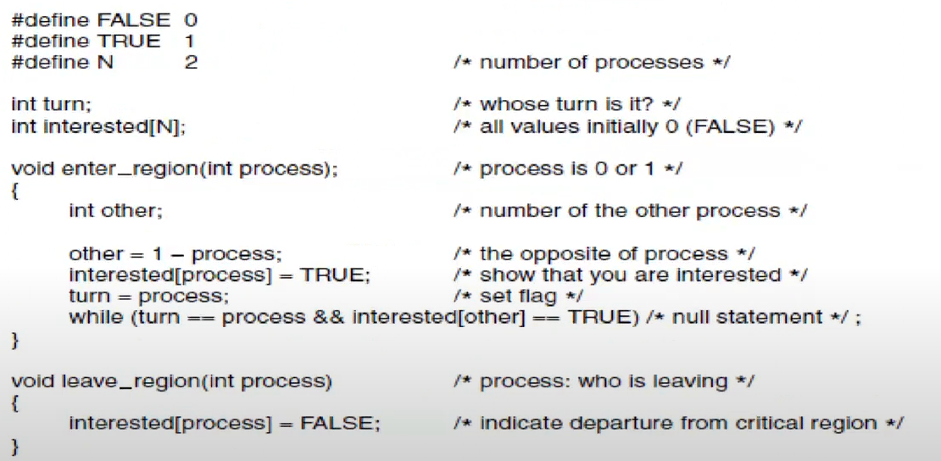

*Peterson’s solution for achieving mutual exclusion*

İki kapılı ev düşün. Process 1 ve 2 kendi kapılarından bu eve girmek istiyor. Girmeden önce içeride kimse var mı yok mu bakıyorlar, yoksa giriyorlar. Aynı anda bakarlarsa ikisi de aynı anda içeri girerler.

Peterson processlerin ilk başta bekleme odasına girmelerini düşünmüş. Processes want to see if other process is waiting in the waiting room. If there is somebody in the waiting room, they cant enter. They are going to wait until other process enters the room and does its job and leaves out.

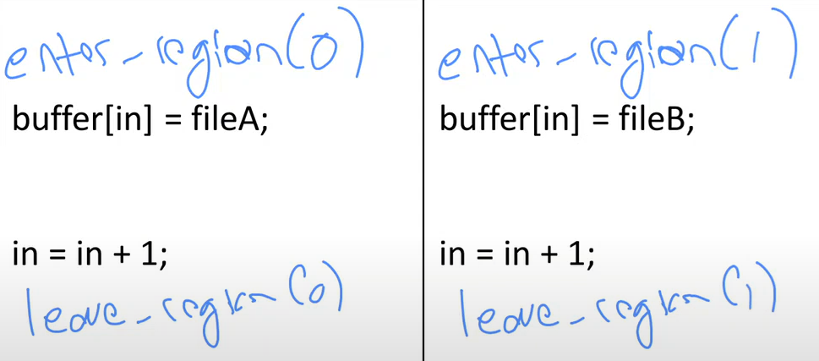

Parameter is process number.

I have global integer turn and array of integers interested.

turn is 0 at the beginning. 2 array elements are FALSE.

interested[0] = FALSE means that process 0 is not interested in going into room.   
interested[0] = TRUE means that process 0 is in the waiting room.

For process 0, other is 1. interested[0] becomes TRUE and turn becomes 0 in the enter_region(0).

There is spin lock – busy waiting at the end of enter_region function. I am trying to enter in this function, I didn’t enter yet. As soon as I leave this function, I am in critical region.

SPIN LOCK FOR PROCESS 0 🡪 If I see that turn is different than 0, then I immediately break the loop and go into the critical region because if somebody else is in the waiting room and if they are trying to enter to critical region, if they changed my turn variable then I will not check if they are interested. Other process who did the change says that “Okay, I changed turn to process, first part of while condition is true for me. If somebody else is waiting for to enter the room, then I will wait here until the other process leave the region. When other process leave, second part of while condition will be false and I will enter to my critical region.”.

If we just look if there is anything waiting to enter the room, both of them would say yes and they will wait until infinity. So we are both checking:

* Is there somebody else in the waiting room?
* Did somebody change turn?
  + That means somebody must be in the waiting room but I am gonna enter the critical region before they do. I know that they will have to wait.
  + If somebody changed it, don’t look if other process is waiting or not. Just go to region immediately.
  + If we don’t check this part and 2 processes are waiting, then this will be infinite loop.

This solution doesn’t have problem of process waiting for the other processes outside the critical region because every time I run enter_region, if other process is not trying to enter the critical region, turn is same as the process and interested[other] is FALSE so I can enter the critical region as many times as I like.

All requirements are fine. No race conditions and starvation can occur.

This is only for 2 processes. If you have more than 2 processes, you have to generalize it. Interested array will be large, there will be no other, you have to check all the other processes if any of them is interested, etc.

Again why do we need mutual exclusion in interprocess communication? To avoid race conditions which occur when multiple processes or threads attempt to access and modify shared resources simultaneously. Mutual exclusion ensures that only 1 process or thread can access a shared resource at a time.

We have never used any help from hardware. Now time has come.

The TSL Instruction

TSL RX, LOCK (Test and Set Lock instruction) – provided by CPU:

* It reads the contents of the memory word “lock” (lock is global variable) into register RX and then stores a nonzero value at the memory address lock.
  + This instruction happens in atomic way. There cannot be any interrupts while I am doing this.
* The operations of reading the word and storing into it are guaranteed to be indivisible – no other processor can access the memory word until the instruction is finished.
* The CPU executing the TSL instruction locks the memory bus to prohibit other CPUs from accessing memory until it is done.

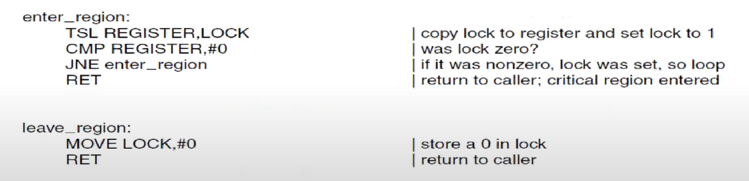

*Entering and leaving a critical region using the TSL instruction*

When I enter the critical region, I call enter_region function.

If lock was 0 at the beginning, it means it is not locked. I can enter the critical region.  
If lock was 1 at the beginning, I make a jump to enter_region to start again. This is SPIN LOCK.

Lock 1 means somebody is in the critical region. If so, 1 is copied into register and lock is set to 1 again. If lock was 0, 0 is copied into register and lock is set to 1.

This generalizes to n processes without any modifications.

CPU has to provide TSL instruction or something similar. TSL is not only way to do hardware supported mutual exclusion.

*Other similar instruction (XCHG):*

This one also atomic. No performance difference but you have to move 1 to register so this is a bit expensive (2 instructions instead of 1). XCHG is more general purpose instruction. TSL is designed purely for synchronization.

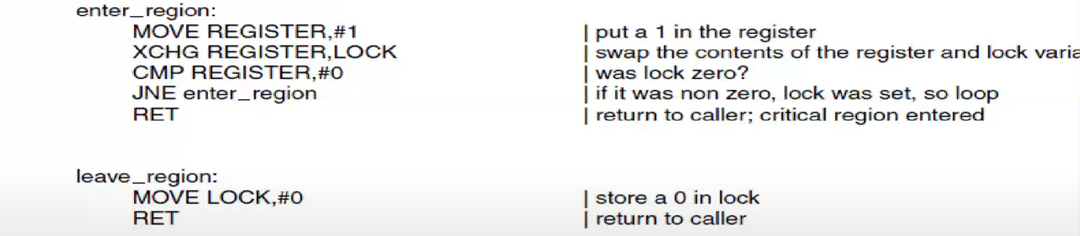

*Entering and leaving a critical region using the XCHG instruction*

Intel CPUs support this instruction.

XCHG REGISTER, LOCK 🡪 Whatever in LOCK is copied in REGISTER, whatever in REGISTER is copied in LOCK. It is kind of swap. LOCK is memory location again.

These hardware solutions are cheaper than Peterson’s solution.

Spin Locks

2 correct solutions – Test and Set Lock, Peterson’s Algorithm – involve busy waiting aka spin lock

Acceptable for short waits, especially on multiprocessors or when dealing with interrupt contexts

For general-purpose use, need a solution that permits sleeping



If single CPU, lets say, A is doing useful stuff in its critical region but B is running the while loop, waiting for A to finish its useful stuff. B is wasting CPU time and also it is making itself late because A cant continue its useful stuff.

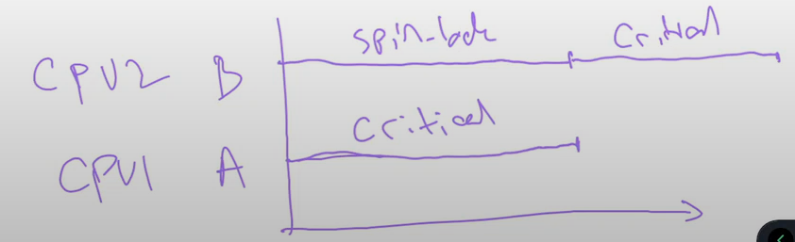

If you have multiple CPUs, B is gonna wait less.

I can run process C in CPU2 so whole system becomes more efficient. So this is least-worst.

Instead of running the loop, why don’t I go to sleep and from time to time I wake up and check if the lock is available. But if I am gonna wait for a short time, you should do the spin lock (especially you are multiprocessor) because sleeping requires system call.

Or maybe whoever is holding the lock, they should wake me up. Maybe I should tell to OS that I am gonna sleep until somebody changes the lock variable in the memory.

Spin Locks and Priority Inversions

Suppose we have 2 processes with different priorities, H and L

L never runs if H is runnable

* Lets say priority of H is bigger than priority of L
* Then if H can run, it will continue running until it is done
* While H is running, L will never get its turn

While H is sleeping, the low priority process L grabs the spin lock

H wakes up and tries to get the lock

It spins, waiting for L to free it

But L cant get the CPU, so it doesn’t progress

This is one example of a deadlock

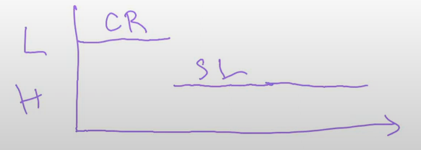CR: critical region

SR: spin lock

Before H has started, L is running in its critical region. As soon as H starts running, the OS says that it is turn of process H and it will start run bc it has higher priority but L is in the critical region. H is running but H is trying to get the lock. It is waiting for L to finish. BUT L cannot finish bc OS will never let it run while H is running. So H will run in an infinite loop.

If we have multiple CPUs; H will run on a CPU, L will run on other CPU. L will finish its job in critical region eventually and release the lock and H can continue. BUT this is only for 2 processes and 2 CPUs. If you have multiple high priority waiting for same lock and that lock is held by a low priority process, doesn’t matter how many CPUs you have, you will run into this problem.

Blocking instead of Busy Waiting

Prevent wasting time busy waiting

Simplest way is sleep + wakeup

* System call sleep causes caller to block (suspend until another process wakes it up)
* Alternatively, sleep + wakeup both have a memory address to match them…

Lets use this in an example

Classic Problem: Producer-Consumer

Producer wants to add elements to bounded-size buffer

* Producer writes to buffer
* Consumer reads from buffer

If buffer is full, producer must sleep

Consumer wants to remove items from buffer

If buffer is empty, consumer must sleep

Example: print spoolers

Process P 🡪 produces files OR produces data OR receives video frames from network

Process C 🡪 prints files that P produced OR send them towards the network OR displays video frames

Since there is communication between these kind of processes, there is always problem of race conditions, they are sharing some memory.

*w/Race Condition:*

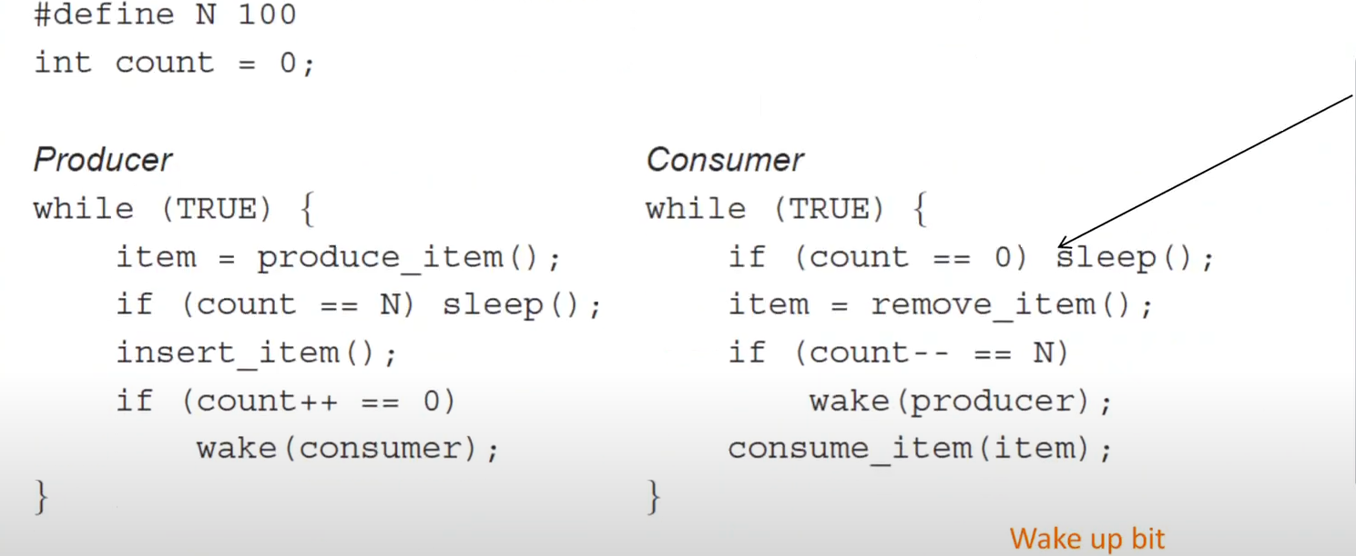



buffer and count are global variables. buffer is used inside insert_item and remove_item.

producing item and consuming item is okay because these are my local variables.

Final result depends on order of running. You don’t want producer produce many things and consumer is not consuming them.

insert_item() 🡪 critical region bc when you are inserting the item and consumer consumes it, then there is race condition.

item = remove_item() 🡪 critical region

count is also global so is it a good way to make red part also critical region?

* Suppose I am in producer and found that count is N. Then I go to sleep in critical region. Producer is gonna sleep until the count is different than N (Consumer wakes it up when count is less than N).
* Nobody can enter the critical region while I im in critical region so consumer will not be able to go into the critical region. So nobody will wake producer up.
* It is a deadlock.

Is making the all codes critical regions good idea?

* It is same thing. Not good.
* If consumer starts, since count is 0 it sleeps.
* If producer starts, it will produce until buffer is full and sleeps.

We will need to do sth complicated.

Semaphores

Invented by Dijkstra in 1965

We use semaphores for synchronization

Semaphore is just an integer

2 operations: down (sometimes known as P) and up (also known as V)

down: decrements semaphore variable if greater than zero; if 0, process sleeps before doing the decrement (sleep). Sleep is until somebody increments it/ups that semaphore.

Note: check, decrement, and sleep are atomic

* While I am doing down, I cannot switch context. It is like TSL or XCHG instructions.
* down is completely atomic means that “I need some help from OS or hardware so that I can be done in atomic way.”.

up: increments semaphore; if a process was sleeping on it, wake it and let it do its decrement (wakeup). up never sleeps. up operation never blocks. It only wakes up any process any thread waiting for semaphore to be incremented.

Generalizes well to multiple users of semaphore

These up and down stuffs are directly supported by OS. They make sure that they are done automatically. Since semaphores are gonna be shared by different processes, semaphores have to be provided by the OS.

*Using semaphores:*

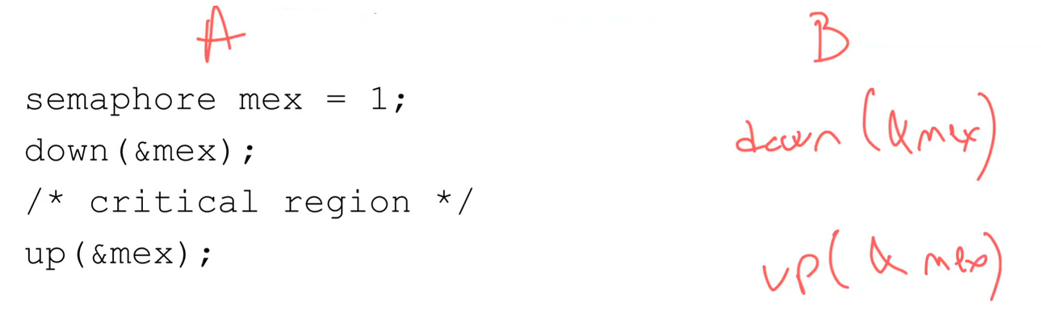



mex: mutually exclusive

read “semaphore” as integer.

While I am in critical region in A, if B tries to get the semaphore down it, since mux value is 0 (bc we downed it before entering the critical region), I cannot decrement it and sleep at blue part. It sleeps until up in A increments the semaphore back to 1. In that case, B will wake up and decrement it with down back to 0 and enter the critical region.

*Implementing Semaphores:*

Typically done in the kernel

Mask interrupts while manipulating semaphore

On multiprocessors, use Test and Set Lock protection as well

Both of these are for only a few microseconds – not a serious problem

Producer-Consumer with Semaphores

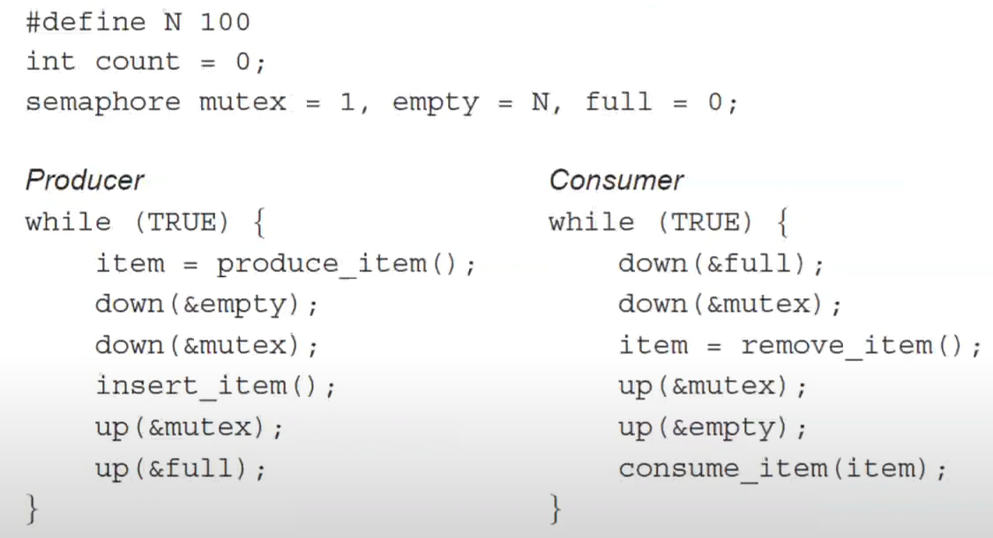



Red parts are critical regions.

mutex 🡪 binary semaphore that will tell me critical region.

empty and full 🡪 semaphores that can change from 0 to N. They are checking the cases of an empty buffer and a full buffer which are bad things.

Another bad thing is both of them are trying to modify same buffer.

If we start with consumer, it will decrement full by 1 but it is already 0 so consumer will sleep until somebody increments full so that consumer can decrement it and continue.

As producer, I produced an item, decrement the empty, which is N, so I made empty is N-1. There is no sleeping. Then I decremented mutex which is 1 to 0. I inserted my item, I made my mutex 1 and incremented full by 1 at the end.

Since full became 1, I can decrement it in consumer. I can decrement the mutex if I am not in critical region in producer. I remove the item, make the critical region available and say that “I am incrementing empty value by one. bc I consumed one.”. Now empty becomes N.

Why do we need mutex (mutual exclusion)? 🡪 Lets say empty is N/2 and full is N/2. I can down empty in producer and full in consumer bc they are nonzero. So both processes can be in the critical region at the same time. If I don’t have mutex.

Two Different Uses of Semaphores

Counting semaphores – atomic way to manipulate a counter with blocking if 0. Regular kind of integers

* In the example, empty counts how many slots are free and full is the # of slots that are full
* Used for sleep/wake when buffer is in the wrong state: synchronization

Mutual exclusion semaphores (mutex-binary semaphore) – make sure only one process is in critical region

* In this case, it protects access to the buffer
* (Probably, that code should be in the insert_item()/remove_item() routines)

Mutexes

Special case of semaphore: useful when no counting is needed: only a bit is enough

If Test and Set Lock Instruction is available, easy to implement at user level for thread package

Try to grab lock; if unsuccessful, let another thread run

If failed to acquire a lock, it calls thread yield to give up the CPU to another thread. Consequently there is no busy waiting.

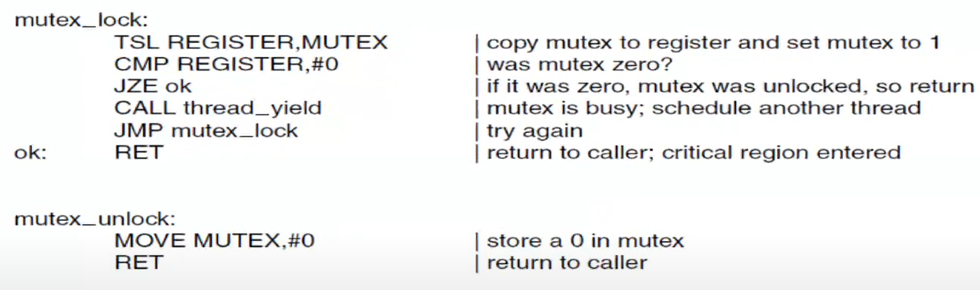

*No busy waiting no possibly infinite loop with threads*

If mutex is 0, then I go to RET. Otherwise I call thread_yield. This thread will sleep until you (OS) wake me up. After I wake up, I go to mutex_lock again and check if lock available again. This is kind of spin lock but very very slow, it is not using much CPU time. This is better than spin locks that spins all the time until the mutext becomes available. Everytime I go to sleep, there is a thread switch and this switch is not as expensive as process switches.

Semaphores and mutexes was in same process between different different threads. Now question is:

Different Processes?

You don’t share same global variables for different processes.

If processes have disjoint address spaces, how can they share semaphores or a common buffer?

One: shared vars are in kernel

Two: Many OSes offer a way for processes to share some portion of their address space with other processes

With shared memory, you can use process synchronization using regular mutexes and semaphores.

Futex (Fast User Space Mutex)

“CALL thread_yield” in the former assembly code may not be that efficient because it is a system call if thread is implemented in the kernel space. System call needs context switch. So sometimes it is better to run a busy waiting spin lock to see if mutex is available.

Busy wait or block: which is faster?

Block only if necessary and switch to kernel space

The kernel service provides a “wait queue” that allows multiple processes to wait on a lock.

* Futex will not make a system call, it will wait for a while, after that it will block the process.

They will not run, unless the kernel explicitly unblocks them.

As a system programmer, you wouldn’t know that you are running a regular mutex or a futex bc they are same, you are trying to get a lock.

*Mutexes in Pthreads (Standard POSIX threads library functions)*

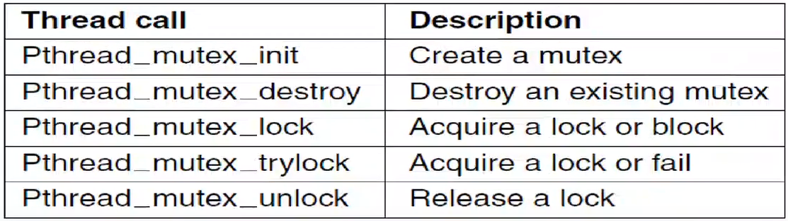

*Some of the Pthreads calls relating to mutexes*

Pthread_mutex_lock 🡪 This says “get me the mutex”. If I can get it, I will get it. Otherwise I will be blocked. So there will be context switch most of the time.

Pthread_mutex_trylock 🡪 This says “get me the mutex”. If I can get it, I will get it. Otherwise it says it didn’t get the mutex. It will not block. You can run your own spin lock then. Try loop 100 times. If you can get it, you can get it. Otherwise call Pthread_mutex_lock.

Condition Variables

What happens with semaphores and mutexes 🡪 Sth has to be 0 to get blocked, I wake up only that thing becomes non-zero.

Condition variables say that maybe there are some other conditions that you like to be blocked on other than sth has to be 0.

You decide under what conditions you are going to be blocked and under what conditions you are going to wake up.

Pthreads offer a second synchronization mechanism: condition variables.

Mutexes are good for allowing or blocking access to a critical region.

Condition variables allow threads to block due to some condition not being met.

Almost always the 2 methods are used together.

*Mutexes in Pthreads (2)*

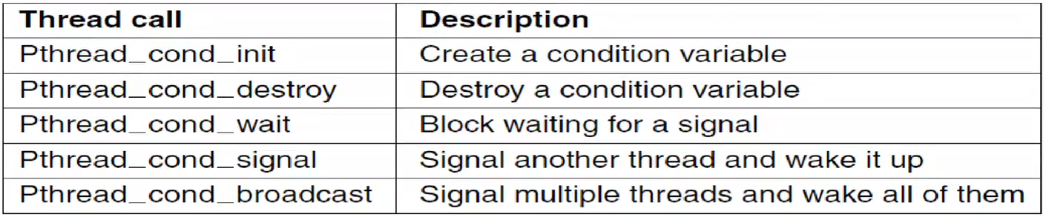

*Some of the Pthreads calls relating to condition variables*

Pthread_cond_wait 🡪 I am gonna wait on what is indicated if statement before this call

Pthread_cond_signal 🡪 If somebody is waiting for this thing to happen and it happened, whatever the condition is we are going to see it. Signals 1 process.

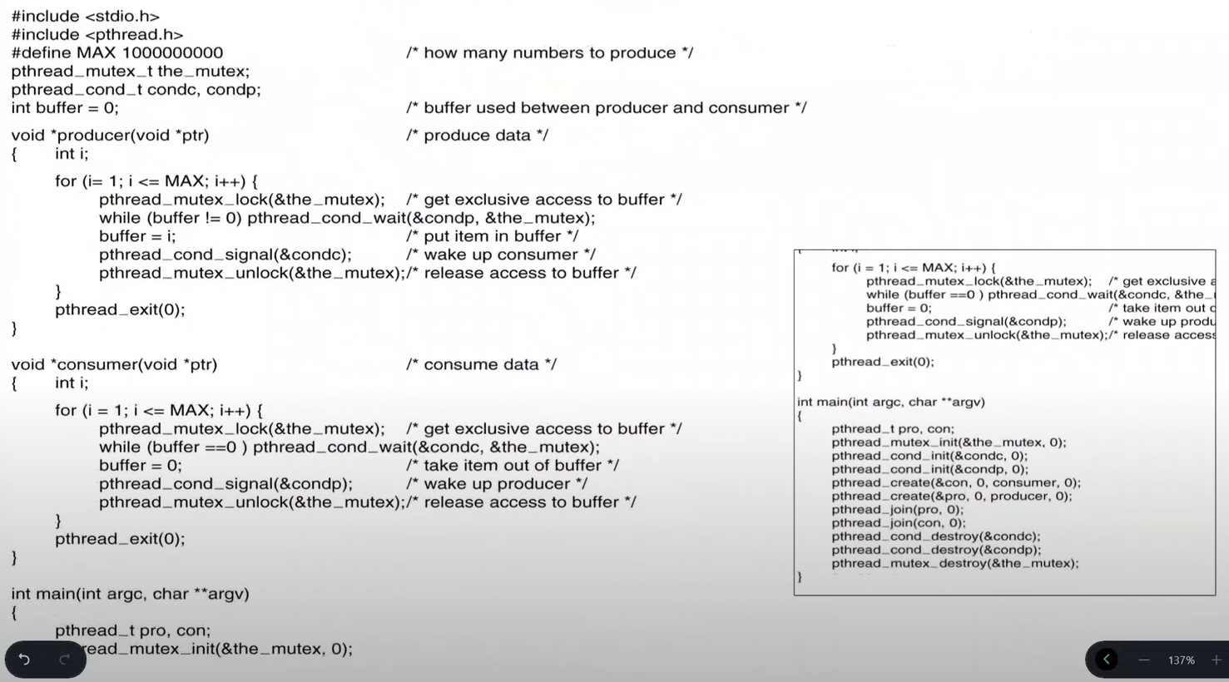Pthread_cond_broadcast 🡪 Signals many processes or threads waiting for that thing to happen.

condc: condition variable for consumer  
condp: condition variable for producer  
buffer: 0 means buffer is available producer can write, non-zero means consumer can take the number   
the_mutex: mutex for critical region

main

pthread_join 🡪 I will wait until pro and con threads are done.

You should also destroy your threads at the end of main.

producer

Critical region is inside the for loop.

As a producer, I need to write to buffer. If buffer is not zero, that means that I had written to buffer before, nobody read it, so I am gonna block. I am gonna wait on this condp to become available until somebody wakes me up on this condition.

“pthread_cond_signal(&condp)” call in consumer is gonna wake me up. Whenever consumer is done with the buffer, consumer makes the buffer 0. Then consumer signals the condp.

Problem is this:

* I am waiting in critical region as producer.
* Nobody can enter the critical region.
* So I need to release the critical region lock, the_mutex.
* That’s why pthread_cond_wait has second parameter. It temporarily releases the_mutex.
* Both processes are in the critical region but one of them does nothing.

With “pthread_cond_signal”, producer is telling to whoever is waiting for this buffer to be available “I am signaling you, you can wake up and do whatever you want.”.

consumer

Critical region is inside the for loop.

Producer and consumer cannot be in critical region at the same time.

If buffer is 0, that means nobody produce anything yet since my last consumption.

Wait until condc and release the_mutex while waiting.

If buffer is not 0, then I consume the buffer and make it 0.

If the producer is waiting for the signal, then signal it. When I signal the producer, since I have the lock, producer cannot immediately start running because I have the mutex lock. When I release the lock, then consumer can start running. Same for producer side.

mutex is either 0 or 1. When we lock it, enter the critical region, it becomes 0. pthread_cond_wait makes the mutex 1. So that other one can enter.

So releasing the lock means making the_mutex 1.

The Risks of Semaphores and Mutexes

Using semaphores and mutexes correctly is difficult

If you get it wrong, you can deadlock

Testing is difficult, because it’s all timing-dependent

We need a higher-level construct

Monitors

Invented by Hoare (1974) and Brinch Hansen (1975)

A programming language construct

Java has it built inside the language from the beginning; C and C++ do not, they add it later with libraries

A monitor is like a class, but only one thread can be executing in it at a time

* So it is automatically giving you mutual exclusion

In other words, they’re a language implementation of mutexes

Monitors have an important property that makes them useful for achieving mutual exclusion: only one process can be active in a monitor at any instant.

Introduction of condition variables, along with 2 operations on them: wait and signal.

When a monitor procedure discovers that it cannot continue, it does a wait on some condition variable, say, full.

This other process, for example, the consumer, can wake up its sleeping partner by doing a signal on the condition variable that its partner is waiting on.

Using the monitors, we don’t have to think about mutual exclusion. It is satisfied by the programming language.

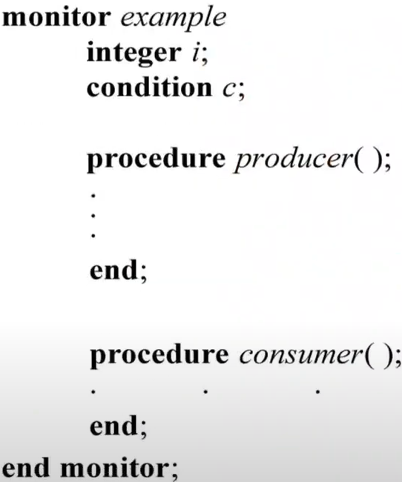Only the producer can be active or consumer can be active at the same time. Programming language satisfies it.

If both of them trying to be active at the same time, there is a mutual exclusion between them.

integer i is buffer again.

With monitors, we get rid of pthread_mutex_lock and unlock calls in the code. I don’t have to think about critical regions.

Monitors and Application Blocking

We still need a way to block if, say, the buffer is full

2 new operations: wait and signal

Subtle semantics about who gets to run within the monitor after a signal call

* Hoare: signaler blocks; waiter runs
* Brinch Hansen: signal can only be done when exiting the monitor
* Or: signaler keeps running; waiter resumes when signaler exits monitor

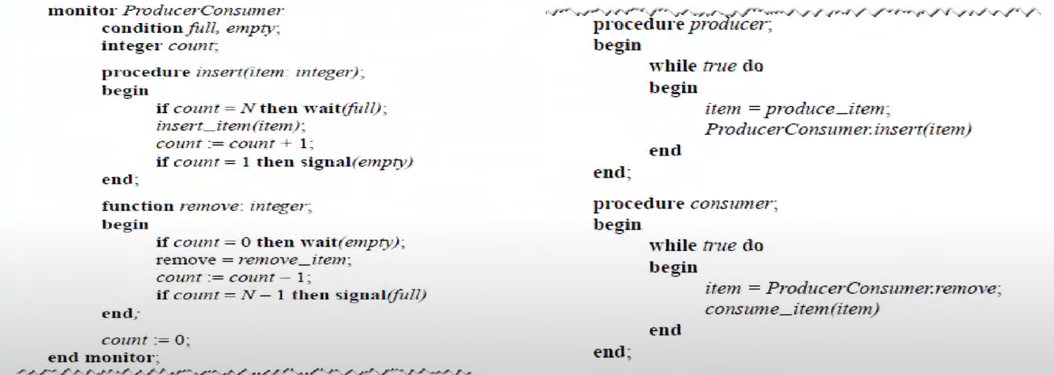

*An outline of the producer-consumer problem with monitors. Only one monitor procedure at a time is active. The buffer has N slots.*

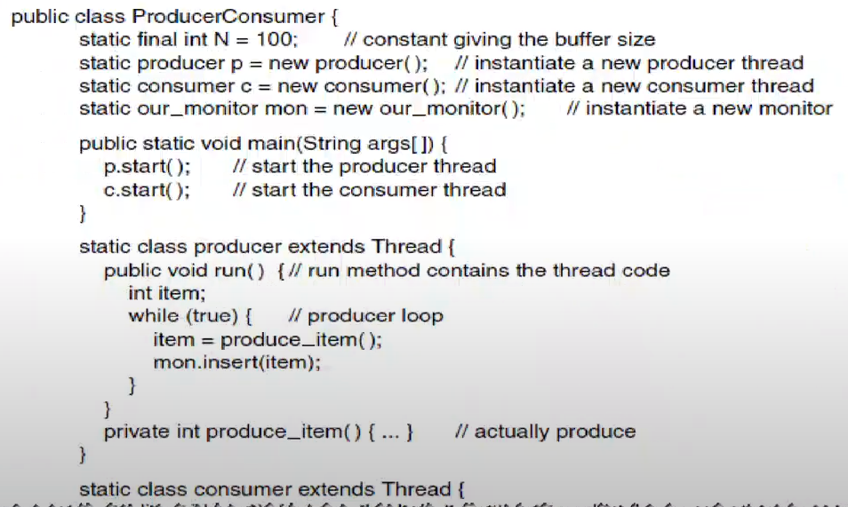

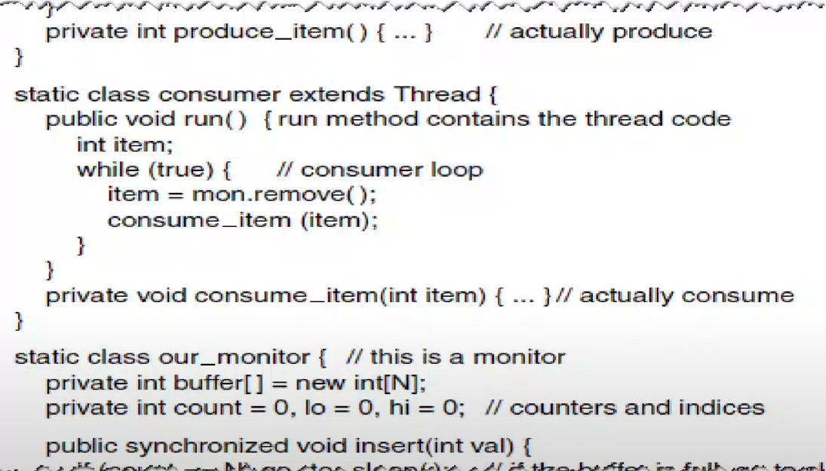

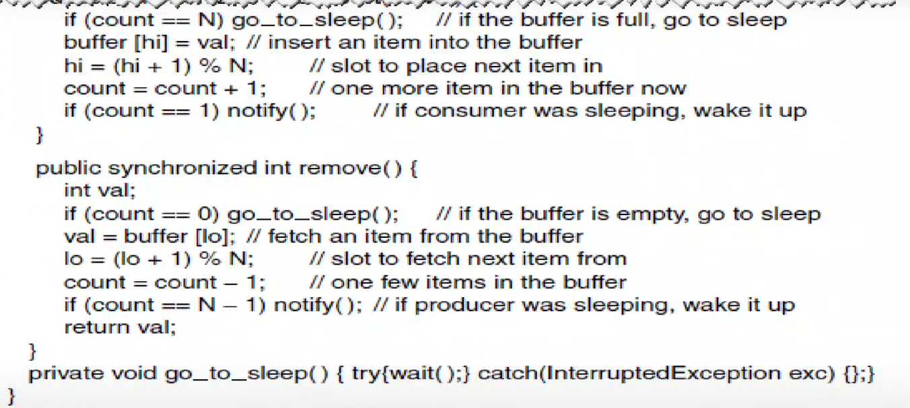



*A solution to the producer-consumer problem in Java*

run method will run when the thread runs. It is extended from the Thread class.

our_monitor is class inside ProducerConsumer class.

Monitor provides 2 things: insert or remove.

* While I am inserting, I cannot be removing.
* While I am removing, I cannot be inserting.

If hi is at the end of the buffer array, it goes back to beginning. So hi can be smaller than lo (both starts from 0, if an element is removed, lo is incremented to point to next element).

insert and remove are synchronized methods. There has to be a mutual exclusion between them. If I am in remove, I cannot be in insert and vice versa. Inside of both methods are critical regions.

notify() comes from Object class in Java. It wakes up single thread, waiting on this object’s monitor.  
notifyAll() wakes up all the threads, waiting on this object’s monitor.

wait() causes the current thread to wait until another thread notifies.

The Disadvantages of Monitors

Monitors are nice, but they are only available in a very few languages

Monitors, semaphores, and mutexes are fine on a single machine, even a multiprocessor

They don’t work well without some shared memory

What about a distributed system connected via a LAN?

Message Passing

Directly supported by OS

Model based on network operations:

* send(dest, &mesg); 🡪 send this message to this process
  + If the receiver is ready, I send this message. Otherwise I get blocked.
* recv(src, &mesg); 🡪 receive a message from this process
  + If the message is ready, I receive it. Otherwise I get blocked.

Receiver blocks if there is no data available

Sender blocks if the receiver’s buffers are full

Complex network questions, including acknowledgement, flow control, error detection and correction, message ordering, and authentication

* all out of scope for this course

The Producer-Consumer Problem with Message Passing

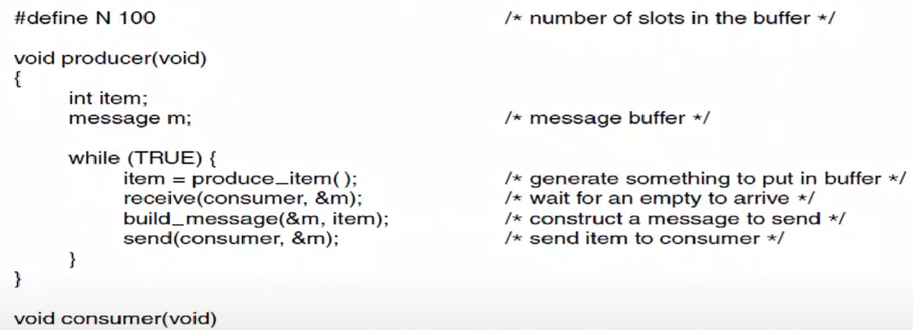

*The producer-consumer problem with N messages*

As a producer, I wait for consumer empty buffer to arrive.

I get a message from the consumer. It is gonna be the message that is empty.

I put my item into this message and send it back.

I am not directly sending it, I am waiting until the consumer sends me an empty message. I put some stuff in it and send it back.

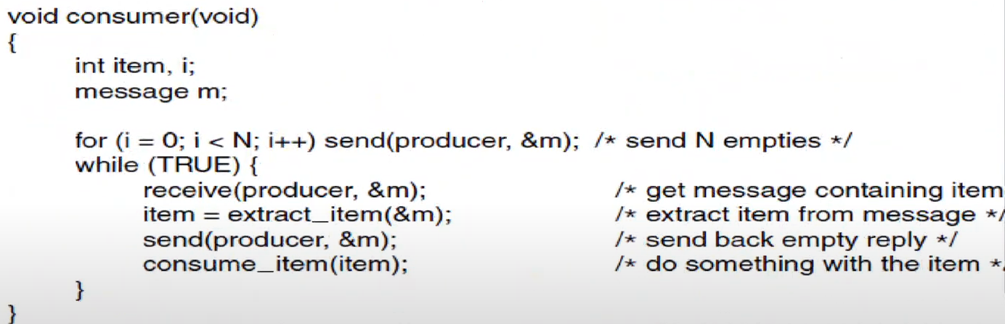

At first, consumer sends N empty messages or buffers.

If I don’t send N empty messages at first, if I keep sending 1 message and wait until I get an empty message back as a producer, that means I cannot produce more than 1 item at the same time. If I keep this unlimited, I kill my network. So at the beginning I produce N empty messages and send them to the producer. Producer receives them one by one, builds them and sends them back.

Producer doesn’t talk about “Do I have enough buffers? Am I waiting for sth?”. As long as you receive and send, you are fine. If there is nothing to receive, you cannot receive.

If you keep your N low, you will be blocked at receiving the messages at both side.

**SCHEDULING**

Suppose several processes are runnable?

Which one is run next?

Many different ways to make this decision

Environments

Old batch systems didn’t have a scheduler (they have only 1 process running); they just read whatever was next on the input tape

Actually, they did have a scheduler: the person who loaded the card decks onto the tape

Hybrid batch/time-sharing systems tend to give priority to short timesharing requests

Still a policy today: must give priority to interactive requests

Introduction to Scheduling Process Behavior

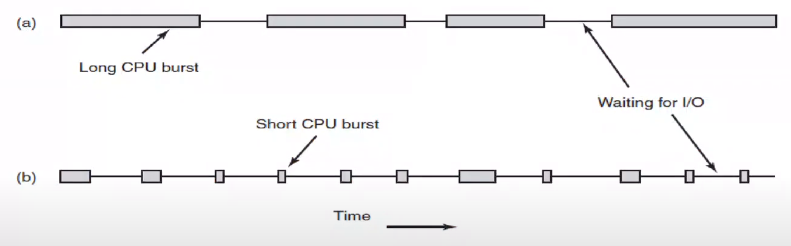

blocked until data is ready

*Bursts of CPU usage alternate with periods of waiting for I/O.*

*(a) A CPU-bound process (b) An I/O-bound process*

Word program is I/O bound.

We don’t usually run CPU bound processes especially on laptops.

As an OS, I should be fair between (a) and (b). OS should give more priority to (b) so that their CPU utilization is about the same.

Process Behavior

Processes alternate CPU use with I/O requests

I/O requests frequently block, either waiting for input or when too much has been written and no buffer space is available

CPU-bound processes think more than they read or write

CPUs have been getting much faster relative to disks

It is better to schedule the I/O-bound processes earlier so that they issue their I/O earlier

When to Make Scheduling Decisions

After a fork – run the parent or child?

* OS knows fork happens bc I do the fork as an OS, it is a system call

On process exit

* exit is also system call

When a process blocks

* process blocks bc it makes a system call for I/O or lock the mutex or to do sth

When I/O completes

* We should do scheduling when I/O completes because some other process is blocked on that result of the I/O.
* How does OS know that I/O completion happened?
  + If I am lucky as an OS, process A will make a system call (for example to cause an interrupt). When the system call is made OS will start running and it will realise that I/O has completed but assume process A doesn’t make any system calls, it keeps a CPU-bound process, it keeps continuing.
  + After some time, timer interrupt will occur and OS handles it. Then OS realizes that there is an I/O completed. Then switch occurs. But we don’t have to wait until timer interrupt happens.
  + When I/O completes, the driver, the controller of that device will cause an hardware interrupt. That will stop the CPU from whatever it is doing, OS will come in and handle the interrupt. After the interrupt OS will make a decision “Should I go back to original process running or there is new I/O completed, maybe somebody is waiting for this data and I will look for it and yes there is somobdy waiting for this data. I will put that in the ready state.”. Now that process can be scheduled.

Sometimes, after timer interrupts (which is also hardware interrupt)

Preemptive vs. Nonpreemptive Schedulers

Nonpreemptive scheduler: lets a process run as long as it wants, only switches when it blocks, when it makes a system call.

* For example when process says give me a key from the keyboard, get me a package from the network, give me this data, write this to disk…
* Not very good at providing interactive services bc if a process is CPU-bound and uses CPU for a second, for that second I cannot do any mouse movements.
* Original of Windows. From time to time OS was freezing. When you do some mouse movements or pressing a key, process start running bc OS can take control of the CPU after that.

Preemptive: switches after a time quantum (system parameter, for example 20 ms).

* OS does lots of things when clock interrupt (hardware interrupt) happens. After some housekeeping jobs, OS will make a decision.
  + We write timer interrupt handling functions as OS designers
* All modern desktop, mobile OS…

Doing preemptive scheduling requires having a clock interrupt occur at the end of the time interval to give control of the CPU back to the scheduler.

If no clock is available, nonpreemptive scheduling is the only option. I have to wait until process gives up the CPU or hardware interrupt to happen like pressing a key or sth.

Categories of Scheduling Algorithms

Batch – responsiveness isn’t important; preemption moderately important

* Batch systems don’t have active users, they don’t have interaction.

Interactive – must satisfy a human; preemption important

Real-time – often nonpreemptive!!

* They put deadlines and deadlines need to be completed in time

Goals – All Systems

Fairness – give each process its share of the CPU

* doesn’t mean all the process get equal CPU time or equal scheduling priority bc sometimes we say this process has more priority

Policy and enforcement – give preference to work that is administratively favored; prevent subversion of OS scheduling policy

* For example, one process has higher priority than other. This is your policy. You have to enforce it to everybody knows about it.

Balance – keep all parts of the system busy

Goals – Batch Systems

Throughput – maximize jobs/hour

Turnaround time – return jobs quickly. Often want to finish short jobs very quickly.

* Given a task, how many seconds should I wait until my process is finished?

CPU utilization

Goals – Interactive Systems

Response time – respond quickly to user requests (quantum and priorities)

Meet user expectations – psychological

* Users have a sense of “cheap” and “expensive” requests
* Users are happier if “cheap” requests finish quickly
* “Cheap” and “expensive” don’t always correspond to reality

Note: Moving sth is cheaper than copying. You just cut the link and tie it again.

Goals – Real-time Systems

Meet deadlines – avoid losing data (or worse!)

* If I promise I will do it in 20 ms, then I should do it in 20 ms.

Predictability – users must know when their requests will finish

Requires careful engineering to match priorities to actual completion times and available resources

We don’t talk about interactivity or CPU utilization. We like to keep some part of CPU idle all the time so that I can meet the deadlines.

**BATCH SCHEDULERS**

Types:

* First-come, first-served
* Shortest first
* Shortest remaining time first

For batch systems:

* Maximize CPU utilization
  + Don’t do scheduling based on preemption, keep the system busy
  + If one of the processes is blocked, let the other run
* Maximize throughput
* Minimize turnaround time

First-Come, First-Served

Run the first process on the run queue

When the running process blocks, the first process on the queue is run next

Never preempt based on timer

* Wouldn’t it be nicer to preempt the running process and switch from one process to another after 20 ms or 50 ms? Assume my OS and hardware supports it.
  + We lost time during the timer interrupt. OS handles it which is piece of software runs on the CPU.
  + Also we do context switching. It takes milliseconds, so expensive.
  + You don’t have to switch between processes. I don’t need interactivity.

Seems simple; just like waiting in line

Not very fair (no preemption means CPU bound processes takes more CPU priority)

* Maybe I may want to preemption for the fairness only, not interactivity.
* Even that case, I would choose quantum time very very long, maybe 4x longer than usual
* With this way, I would more satisfy the fairness and keep # of context switches low

Doesn’t care about the throughput or turnaround time

Shortest First

Suppose you know the time requirements of each job

A needs 8 seconds, B needs 4, C needs 4, D needs 4

* It is gonna take 20 seconds all together doesn’t matter the which runs first
* CPU is utilized all the time
* Total time is always same. It takes 20 seconds to complete all the jobs. That’s my throughput.

Run B, C, D, A

Nonpreemptive

Provably optimal turnaround time:

* Suppose 4 jobs have runtimes of a, b, c, and d
* First finishes at time a, second at a + b, etc.
* Mean turnaround is (4a + 3b + 2c + d)/4
* d contributes less to the mean

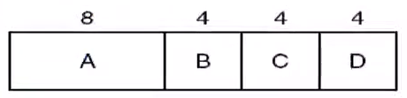 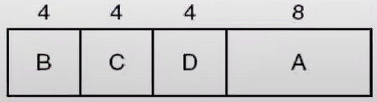

for process B to finish, it takes 4 seconds  
for process C to finish, it takes 8 seconds  
for process D to finish, it takes 12 seconds  
for process A to finish, it takes 20 seconds

Add them up and divide by 4:  
 44/4 = 11

Average of 11 seconds per job.

for process A to finish, it takes 8 seconds  
for process B to finish, it takes 12 seconds  
for process C to finish, it takes 16 seconds  
for process D to finish, it takes 20 seconds

Add them up and divide by 4:  
 56/4 = 14

Average of 14 seconds per job.  
(Turnaround time per job)

Somebody has to finish in 20 seconds. I prefer it to be longest one to don’t make anybody waits.

Better turnaround time than first-come, first-served.

I have all the jobs and I know how much they are gonna take bc I run them before. It is not like interactive processes. We cant know how much the word process will take in terms of CPU time. It depends on how much you use it.

You know all of your processes, what if we don’t have all the processes and they come later?

Optimality Requires Simultaneous Availability

Jobs don’t all arrive at the same time

Cant make optimal scheduling decision without complete knowledge

Example: jobs with times of 2, 4, 1, 1, 1 that arrive at times 0, 0, 3, 3, 3

Shortest-first runs A, B, C, D, E; average wait is 4.6 secs

If we run B, C, D, E, A; average wait is 4.4 secs

While B is running, more jobs arrive, allowing a better decision for the total load

At the beginning, I cant know that there will be a process C that takes 1 second

We need sth else!

Shortest Remaining Time Next

Preemptive variant of FCFS

* Depending on how much time left for that process to finish, I can make a scheduling decision

Still need to know run-times in advance

When a new job arrives, its total time is compared to the current process’ remaining time

Helps short jobs get good service

May have a problem with indefinite overtaking

For the previous example, A runs first, then B runs. While B is at its 1st second, C arrives. Scheduler says that C is gonna take only 1 second. Remaining time of B is 3 seconds. So I am gonna just kinda preempt so B is gonna run for 1 second, then C, then D, then E, then B again for 3 more seconds.



It is not doing preemption based on the timer, it is doing preemption based on who come next and how much time it needs on my CPU.

In batch systems, we don’t prioritize one job to other one. There is no high priority but fairness is important.

Latency Numbers

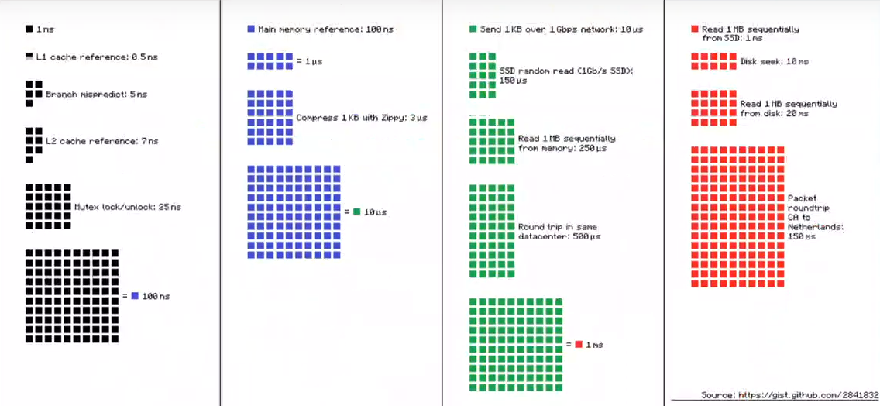

Context switches are very expensive.

When you do context switch, L1 and L2 will be invalidated. For MBs of data, you have to go to main memory and populate it again and that costs a lot.

**SCHEDULING IN INTERACTIVE SYSTEMS**

Round-Robin Scheduling

* Other ones are kind of variations of this type of scheduling

Priority Scheduling

Multiple Queues

Shortest Process Next

Guaranteed Scheduling

Lottery Scheduling

Fair-Share Scheduling

Round-Robin Scheduling

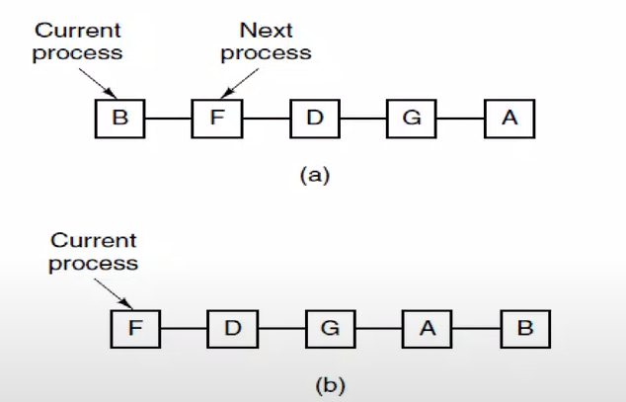

*Round-Robin Scheduling*

*(a) The list of runnable processes*

*(b) The list of runnable processes after B uses up its quantum (or blocks)*

This is kind of circular linked list and I go one by one.

Quantum is system parameter.

In terms of CPU utilization, I am not waiting for anything. I am not keeping CPU idle.

Although, this is interactive system. We don’t talk much about CPU utilization.

This is okay in terms of fairness.

My policy is interactivity. For example, for 100 ms, if I spend 20 ms for each of them. In a given 100 ms, each of them will use the CPU. So each of them has possibility to responding to the user. It is interactive enough.

BUT maybe some of the processes has more importance. Maybe they shouldn’t get equal amount of CPU time. That’s where priorities come into play.

One of the oldest, simplest, fairest, and most widely used algorithms is round robin

Each process is assigned a time interval, called its quantum, during which it is allowed to run.

If the process is still running at the end of the quantum, CPU is preempted and given to another process.

If the process has blocked or finished before the quantum has elapsed, the CPU switching is done when the process blocks, of course.

*Quantum Length*

The shorter the quantum, the more responsive the system

However, process switching is expensive (saving and reloading registers, switching virtual memory maps, flusing the cache, bookkeeping, etc.)

Suppose the computer quantum is 4 ms and process switches take 1 ms

That’s 20% overhead – too much

* 20% of CPU time will go to context switching

Suppose we have 100 ms quantum

If the run queue ever gets long, even cheap requests will take too long

Need a reasonable compromise: 20-50 ms?

We like to keep context switches minimum and we like to stay as interactive as possible. We need to find a balance.

For the preemptive batch systems, you should keep your quantum time very long bc you don’t care about interactivity, it is for fairness. So 100 ms may be good.

Priority Scheduling

Not all processes are equally important

Assign them priority levels

Simplest version: run the round-robin, always run the highest-priority process in front of others

Not a good idea – what if it’s CPU bound?

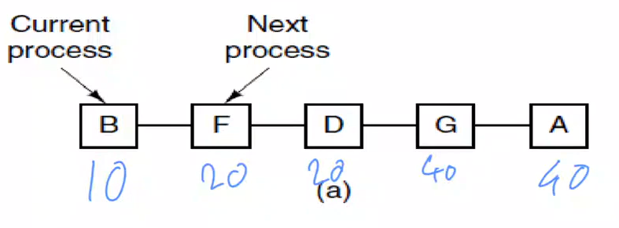

When quantum time for B is over, the scheduler checks whose priority is highest in the queue. Again it is B. So I am gonna let it run again.

B will run until it is done or it is blocked or it is terminated bc it has highest priority.

If B’s priority is 20, then B will be placed between D and G.

G and A may starve in these situations. That’s against the rule of fairness.

This is also bad in terms of priority inversion problem.

***Priority Inversion Revisited***

Strict priority scheduling can lead to a phenomenon called “priority inversion”

Consider the following example where p(H) > p(M) > p(L)

* H needs a lock currently held by L, so H blocks (H is sleeping)
* M that was already on the ready list gets the processor before L
* H indirectly waits for M, (no deadlock but priority inversion)

On Path Finder (they spent 1-2 weeks to figure out what’s happening with path finder which is Mars robot), a watchdog timer noticed that H failed to run for some time, and continuously reset the system

* It takes 8 months for robot to go to Mars
* They have to do sth critical but computer started booting itself over and over again
* High priority process didn’t run bc it is waiting for low priority task to release the lock
* Some other process (watchdog timer) noticed it and it says “H is not running, it is important so I am gonna reset the system so that it can run.”. But when it starts, it happens over and over again.

*Priority Adjustments*

Periodically reduce the priority of the running process

Eventually, it falls below the priority of the next process

Alternative: increase the priority of non-running processes

Called **process aging**

Or do both

Lets say P1 uses 2 ms of CPU time, P2 uses 10 ms of CPU time. They run in round-robin style. How you set the quantum time?

* If I run them without adjustment, it is P1 – P2 – P1 – P2… which is 2 ms – 10 ms – 2 ms – 10 ms. So P2 will end up using CPU time more.
* In terms of fairness, you keep quantum time of P2 low. Force it to switch. You like to give more opportunity to P1. Interactivity also increase.

***Dynamic Priority Adjustment***

Adjust process priority according to its recent history

* Example: increase priority of non-running processes; decrease priority of running processes

Boost priority of I/O-bound processes

* because they cant use quantum time given to them.
* I increase priority of them so that they can get the CPU time they deserved.

If process used 1/f of its last quantum, boost its priority proportional to f. Set the priority to 25, where 1/25 is the fraction of the last quantum that a process used.

* Next time when I run, I am gonna do same thing again. I am not gonna use all of my quantum time but I will get more chances of using the CPU bc my priority is higher.

Use priority classes: have separate queues for each priority level, and run each queue round-robin; switch to lower-priority queue when this one is empty

Run Queues

Each run queue is a linked list

To raise or lower a process’ priority, move it to a different list

Two schemes for priority aging:

* Not many processes: have a fine-grained counter for each process incremented at a clock interrupt; at some limit, increase priority
  + Each process can have its own priority number
* Lots of processes and queues: periodically, move each list to the next level up
  + Keep priority classes

***Priority Scheduling***

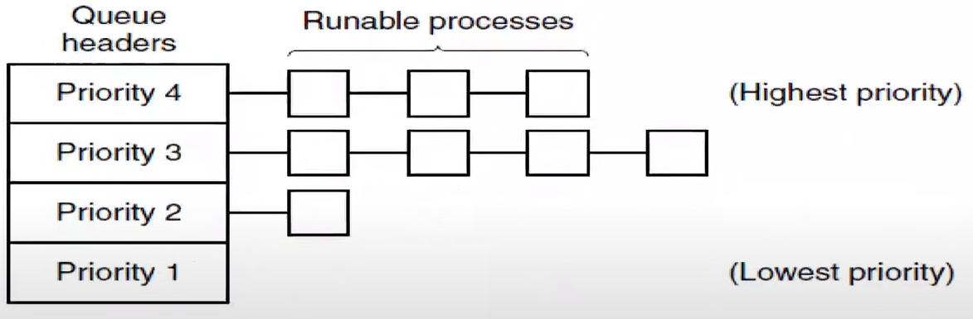

*A scheduling algorithm with 4 priority classes.*

Priority 1, 2, 3, 4 are priority classes.

I keep running round-robin schedulers one for each class.

If I have processes running for priority class 4, other classes will not get any chance of using the CPU. It is against the fairness so we will do the priority adjustments.

If I see, as an OS scheduler, priority class 3 is not getting any CPU time, maybe I should add all of 4 processes of it to priority 4 class. OR maybe I can join 3 and 4 priority classes together.

In batch systems, we don’t talk about priorities. Usually all the jobs are equally important there.

For interactivity systems, some processes are for interactivity and they have to be done early. Their quantum time is small and priorities are high usually.

***Varying Quanta***

Many processes need just a little bit of CPU time

Since process switches can be expensive, don’t do them too often

Solution to both problems: give lower priority queues longer quanta

Top priority queue: 1 quantum

Second queue: 2 quanta CPU allocation

Third queue: 4 quanta, etc.

Alternate solution: “short” (initial) quantum at high priority (interactive) and “long” quanta at low priority thereafter

When you start a process, it starts with a priority which is static priority.

How do we know a process is interactive?

* We had lots of terminals connected to mainframe computers with the keyboards.
* Each terminal is running a single process.
* That’s what it used to be.
* For this computer to understand what kind of job this terminal (one of them) is running, it used to look at the keyboard clicks.
* If I am clicking on my keyboard, that means I am an interactive process. So I would increase priority of those processes that uses the keyboard a lot.
* Some people figured this out and even though they are not running an interactive process, they just sit in front of the computer and keep pressing the page down button all the time. So their calculation has more priority, it runs faster.

Nowadays, we have statistics. We have “How many times that process asked to OS to get the mouse clicks?”. That’s a good indication of how interactive that process is.

***Helping Interactive Processes***

Look for signs of user input

When they occur, give the process a very high priority

Example: on CTSS, when a user typed a carriage return, the process got top priority

Harder to do today – what’s “interactive” on a networked process? For a mouse movement, which process is credited?

***Process Priorities***

What processes should have higher priorities?

Administrative issues

System performance

* Kernel processes (up to a point)
  + If there is a kernel process needs to run, then usually it has highest priority
* Interactive service processes (i.e., X server)
  + If you are taking backup of your system, maybe that should have the lowest priority

Users can lower priority of their own processes, sometimes to avoid competing with themselves

***Unix Priorities***

Tradition: lower numbers indicate higher priorities

“Nice” value is a user-specified modifier

* nice command lowers the priority a little bit, by 10 (if it is 80, it becomes 90)

A nice value of +20 specifies a very low priority process

You cant increase your priority

Only root can set negative niceness

Default is 0 (sanırım 10 olması lazım yanlış yazılmış)

Note: this is an API; internal metric can be different

***Some Linux Priorities***

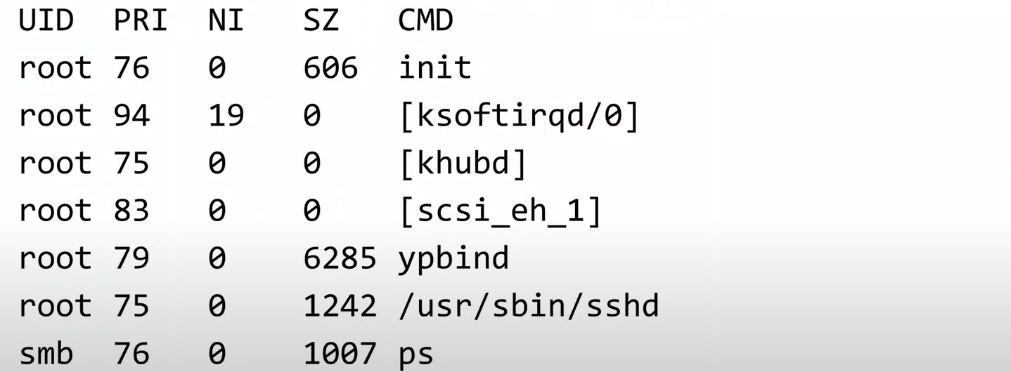

*The PRI value factors in the niceness and the process’ dynamic priority*

Shortest Process Next

Sometimes we say “Why don’t we use the same thing that we did with the batch systems?”.

* Batch systems run the shortest process first.
* For interactive systems, determining which one is gonna block first is a difficult thing but sometimes we get the estimates depending on how much time I use. For that one maybe I can run the shortest process next. Give the priority to shortest process bc I know that it is gonna be blocked. So that must be an interactive process.

Running shortest process first decreases the turnaround time. We are not talking about the turnaround time this time bc in interactive processes, we don’t have turnaround times. We don’t want to complete our word process in a shorter duration. It is an interactive process, it keeps blocking anyways.

We try to give more priority to shortest processes bc they are interactive and don’t use the CPU much.

We can look how much CPU time it used before.

Can we emulate batch systems’ shortest first algorithm?

It’s hard, because we don’t have good estimates

Instead, use historical data for a moving, decaying, average

Let first time = T0; second is T1

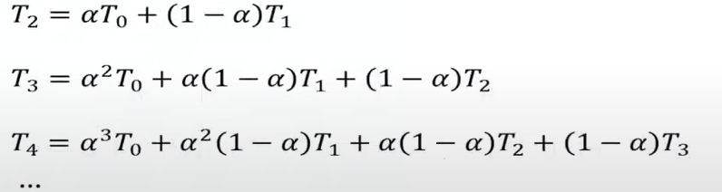

T2’ is estimation that how much this process is going to use CPU next time.

Alpha is a number between 0 and 1. If it is 0.25, it gives more weight to T1 than T0.

Primes are estimates, others are measured times.

T3’ = $α$. T2’ + (1 – a) . T2

We can figure out how much time it’s gonna take for a process to block and prioritize our processes. Run the shortest process next.

We are being fair for the processes that run short.

Guaranteed Scheduling

For n users or process on a system, give each 1/n of the CPU

Measure actual CPU usage

* If they are using exactly 1/n of the CPU everytime they run, then I am fine.
* Otherwise, I look at the ratio how much time they used and 1/n.
  + If they are using more than 1/n, then decrease their priority.
  + If they are using less than 1/n, then increase their priority.

Calculate process’ CPU time entitlement

Look at the ratio of the two: 0.5 means it’s had only half of the CPU it’s entitled to, so it gets priority over a process with a ratio of 2.0

We sometimes ask user to choose between scheduling algorithms for interactive computers on simulated environments.

Lottery Scheduling

Give each process lottery tickets

Higher priority processes get more tickets; lower priority process get fewer

At scheduling time, pick a random ticket

The process holding that ticket gets to run

Note: tickets can be exchanged between processes, such as between client and server

I have these processes and their corresponding priorities:

* P1 10
* P2 20
* P3 20
* P4 60

Assume there are 100 lottery tickets numbered 1-100. Since P1 has the highest priority, I would give tickets 1-40 to it.

* P1 1-40
* P2 41-65
* P3 66-90
* P4 91-100

Then I pick a number. Lets say 23. This number belongs to P1. So P1 use the CPU. So P1 has highest probability to run the CPU.

Lower priority jobs still have smaller chance of using the CPU. So they won’t starve.

If I see one of the processes is not using the CPU at all, then I would give more tickets to that process. So tickets can be exchanged between processes.

If a process says that “I am blocked and waiting for a lock to be released, so I give up all of my tickets because I am blocked, I am in a spin lock.”. Priority donation can be implemented very easily with this lottery scheduling.

Fair-Share Scheduling

Similar to guaranteed scheduling.

In some systems, processes don’t compete, users do

* I have user 1 (U1), U2, U3.
  + U1 is running P1, P2
  + U2 is running P3
  + U3 is running P4, P5, P6
* If I do guaranteed scheduling between the processes, U3 will get the more CPU time, it shouldn’t be the case
* Lets say U1 uses 50% of the CPU. Then priorities of P1 and P2 will be dropped by some amount so that U1 will use only 1/3 of the CPU and
  + P1 gets 1/6
  + P2 gets 1/6
  + P3 gets 1/3
  + P4 gets 1/9
  + P5 gets 1/9
  + P6 gets 1/9

We don’t want to encourage forking just to get a larger share of the CPU

Solution: make decisions based on user CPU consumption instead of process CPU consumption.

Priorities, etc., can still apply

OS is another user, what about it?

* We like to be fair between the users but OS has more priority.
* I can say OS will have more priority than user processes.

**REAL-TIME SYSTEMS**

Meet deadlines – avoid losing data (or worse, losing whole system! Your whole system may become non-functioning, irrelevant.)

* If an event occurs, for example a key press, I need my answer in 20 ms (as example). It may become under 20 ms but it CANNOT become over 20 ms.
* In interactivity, I should response asap. It is not asap in real-time systems, we want guarantees. It is always predictable.

Predictability – users must know when their requests will finish

Requires careful engineering to match priorities to actual completion times and available resources

Most of the real-time systems are very simple. In their lifecycle, they have equal slots for processes (20 ms):



I guarantee that A will run every 80 ms and it is gonna take 20 ms. So response time of A is guaranteed to be 80 ms.

IDLE is just in case that, for example, C took 25 ms.

None of the processes will run later than 80 ms. Maybe sometimes one of them will take more than 20 ms but IDLE will handle that part.

You might say, in a mechanical world, like mechanical HDD, from time to time bc it is mechanical, it might be late. They might do some maintenance task that they need to perform. Then you cannot use mechanical harddrives in a real-time system bc they are not reliable in terms of their response time.

Scheduling is very simple. We don’t say A is gonna run or B or C. Everybody has their own allocated slot time. You are supposed to run at most 20 ms (for example) and get blocked.

What happens if they are not blocked? What happens if A keeps using the CPU after 20 ms of time?

* If A do this, whole system fails.
* B and C will not use the CPU. We don’t like starvation. Especially for real-time systems.

How do I control A?

* We don’t use preemption in real-time systems.
* Processes are carefully written in real-time systems. They are part of the system. They are not regular, ordinary, end-user programs. They are designed with the system itself. They are written in a way that they run at most 20 ms.
* You cant install your own program to a real-time system. It comes with its own set of programs. Real-time systems are specialized for purpose. That’s why you don’t find any preemption in real-time systems. OS doesn’t have to preempt any program by taking the CPU away.

hard real time, meaning there are absolute deadlines that must be met – or else! There’s no tolerance.

soft real time, meaning that missing an occasional deadline is undesirable, but nevertheless tolerable

* For example, a video player. It should show 1 image frame at every 50 ms. For 1 second, I should show 20 frames.
* From time to time, every 2 minutes lets say, I miss a frame. Usually people don’t realize anything. Even they notice it, it is tolerable.
* But if I miss 1 frame every other second, that’s not tolerable.

Periodic Events

Many real-time events occur with a regular frequency

Suppose there are m events, with event i needing Ci seconds of CPU and occurring every Pi seconds

System works if and only if:

$\sum_{i=1}^{m}{\frac{C_{i}}{P_{i}}}≤1$

Watch out for process switch overhead…

If I can fit all of the processes in my memory, I can run them on my Windows machine. If I run too many processes, my computer gets slow but it is still runnable.

It is not same for real-time systems. I cannot put process D and E on the computer with timeline in previous page bc I don’t have enough slots. If I put 2 more processes, then I cannot schedule all of these 5 processes. I cannot meet the deadlines anymore.

We should be careful about the decision that “Can I schedule this many processes?”.

***Schedulable real time systems***

A soft real-time system with 3 periodic events, with periods of 100, 200, and 500 ms respectively.

If these events require 50, 30, and 100 ms of CPU time per event, respectively, the system is schedulable because:

0.5 + 0.15 + 0.2 < 1

*In other words:*

Process A In 100 ms I will run (period) and I will use 50 ms of CPU time (CPU usage)

Process B In 200 ms I will run and I will use 30 ms of CPU time

Process C In 500 ms I will run and I will use 100 ms

Can I schedule these 3 on my real-time system?

* 50/100 = 0.5 🡪 A will use 50% of the CPU
* 30/200 = 0.15 🡪 B will use 15% of the CPU
* 100/500 = 0.2 🡪 C will use 20% of the CPU
  + Total is 85%. I am using 85% of the CPU.
  + It is okay. I am not exceeding my total system CPU time.
  + It is schedulable.

Aperiodic Events

Other events don’t happen on a regular schedule

The basic constraint is the same: total load must be less than total capacity

Engineering such systems is harder

* Most common one is 🡪 everybody has allocated slot and you run only in that slots

Sometimes it might happen. I don’t have any guarantees that I am gonna run every 200 ms. Basic idea is same, you can’t use more than 100% of the CPU.

**THREAD SCHEDULING**

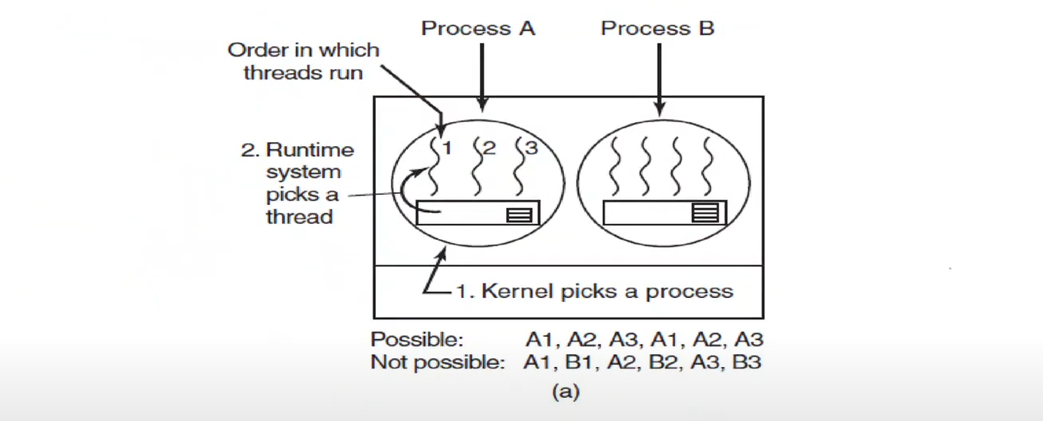

*(a) Possible scheduling of user-level threads with a 50 ms process quantum and threads that run 5 ms per CPU burst.*

At the user level for process A, I can schedule thread number 1, 2, 3, 1, 2, 3… etc. There is no more I can do.

When you switch from process A to process B, then it becomes B1, B2, B3, B1, B2, …

If I am doing it with kernel level scheduling, I can do intermixing.

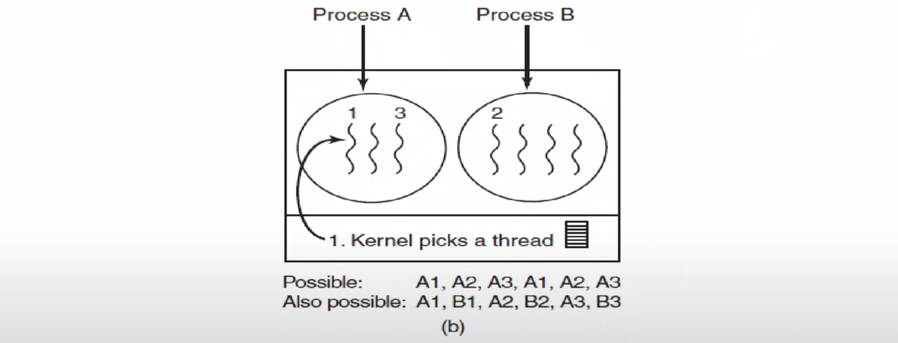

*(b) Possible scheduling of kernel-level threads with the same characteristics as (a).*

As you see, thread scheduling is more flexible if you do kernel level thread implementation.

Although, switching from A1 to B1 is more expensive. It requires you to switch the address space too bc A1 and B1 has different address spaces while A1 and A2 has same address space. It is expensive bc when you change the address space, the caches are invalidated bc I cannot keep the cash contents the same. They have to invalidated and repopulated.

Since the kernel knows that switching from a thread in process A to a thread in process B is more expensive than running a 2nd thread in process A, it can take this information into account when making a decision.

User-level threads can employ an application-specific thread scheduler: for example, the Web server.

Suppose that a worker thread has just blocked and the dispatcher thread and 2 worker threads are ready. Who should run next? Dispatcher should run next.

Thread scheduling is no different than process scheduling.

The only thing I need to be careful is which one is causing more overhead time: between process or in-process switching.

The Dining Philosophers Problem (classical problem about inter-process communication)





*Lunch time in the Philosophy Department.*

I have 5 philosophers: P1, P2, P3, P4, P5.

P means also processes.

Each process (philosopher) is either thinking (computing) or eating (doing I/O).

If it thinks, it doesn’t need anything, it just does computation.

When they eat, they need to take both 2 forks next to the plate. Forks are actually resources (like scanner or printer). One process will scan document (fork), do sth (spaghetti), and print it (other fork).

Resources have to be shared between the processes.

For doing I/O, process 1 needs both of the forks R1 and R5. Sometimes R5 is used by P5. That means P1 and P5 cannot be eating at the same time bc R5 is not sharable, it will be used either by P1 or P5.

P1 and P4 can be active at the same time.

How many philosophers can be eating at the same time? At most 2.

I need to come up with an algorithm that doesn’t cause any race conditions that will let 2 process eat at the same time happen.

They can think as much as they want. It doesn’t require any resources or forks but eating does. Also you have to share your fork with your neighbour.

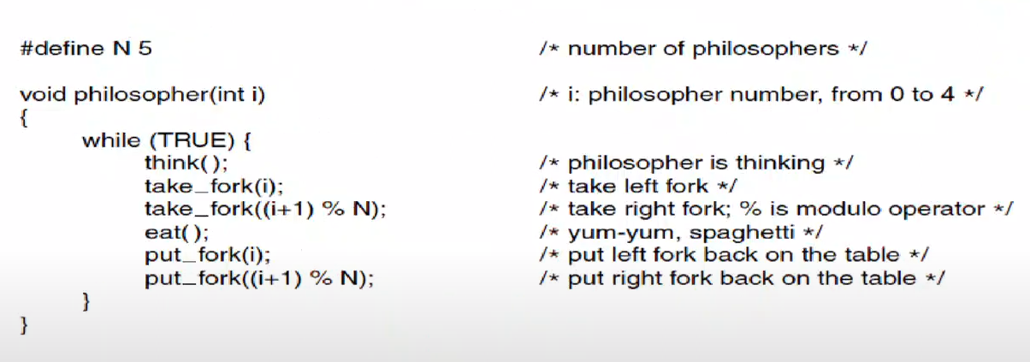

*A nonsolution to the dining philosophers problem*

Each one of 5 philosophers is running the same philosopher function simultaneously.

Assume P2 is running and it took the R2. Then switch happened.

P3 took the R3. Switch happened.

P2 is trying to get the R3 but it cant because it is taken by P3.

P4 starts running and took the R4. Switch happened.

P3 is trying to get the R4 but it cant bc it is taken by P4.

P5 starts running …

AT THE END

* P2 will be waiting for P3
* P3 will be waiting for P4
* P4 will be waiting for P5
* P5 will be waiting for P1
* P1 will be waiting for P2

THERE WILL BE A DEADLOCK!

Lets use mutex:

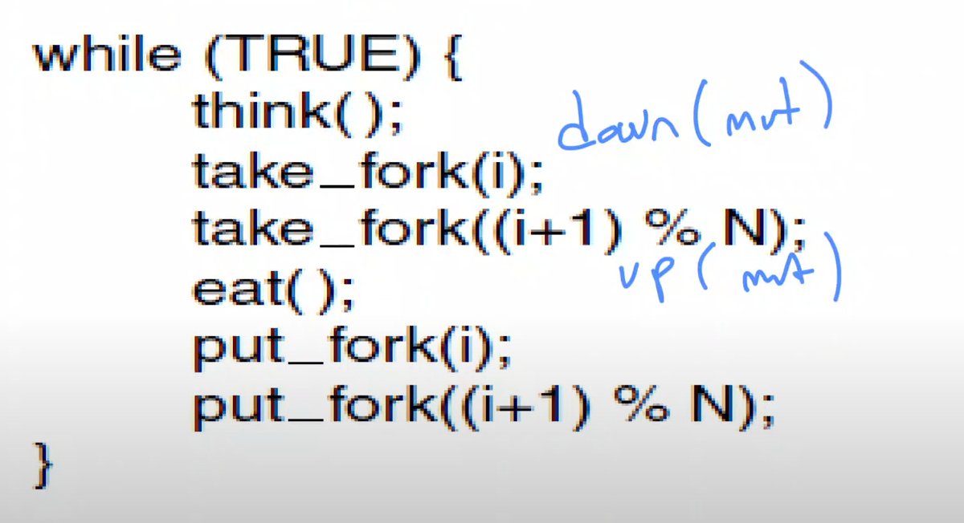

Before I take fork i after the down(mut), no other process can enter the critical region. So they cannot take anything. So I can take both forks, eat, and then release them.

If we put up(mut) at the end of the loop, at most 1 process can eat at the same time. It doesn’t cause any race conditions or deadlocks but only 1 process can eat at the same time.

What we did is also bad idea.

Lets say P1 is eating. It took both R1 and R2.

Then P5 is trying to wake up and P1 is eating. P5 is trying to get R5 and R1. P5 can go into the critical region because P1 is in the eating process, it came out from the critical region.

P5 is going to take R5 but it cannot get R1 bc P1 is holding it. P5 is going to be blocked inside the critical region. P5 is holding the lock, waiting for R1.

Then P4 wanted to eat and it needs R4 and R5. P4 cannot take any forks even tough both forks are available because it cannot enter the critical region. Critical region is held by P5.

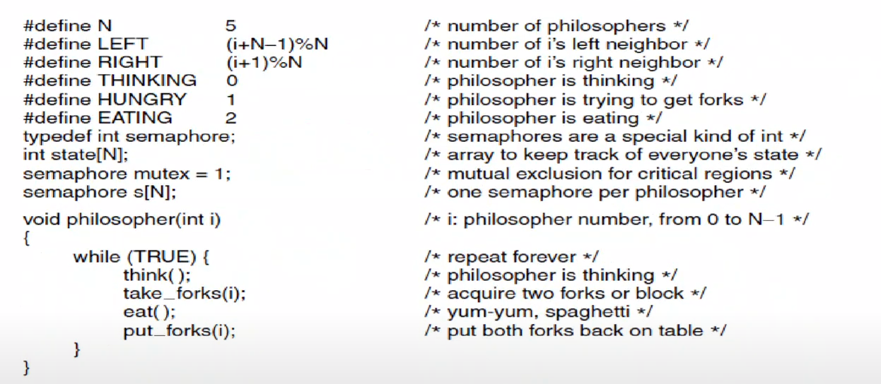

*A solution to the dining philosophers problem.*

When semaphore is 0, then it blocks.

s is [0, 0, 0, 0, 0] initially.

thinking and eating are trivial.

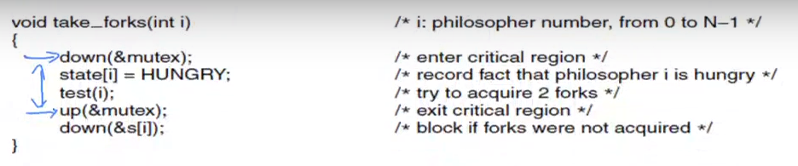

Critical regions is indicated. I CAN BE BLOCKED IN WHERE down FUNCTIONS ARE.

* First down is for mutual exclusion
* Second down is for waiting for the forks
  + I am not blocked if my right and left are not eating and I am hungry but if I am blocked,
  + Will be released when my left or right neighbour tests me when they release forks

If I try to decrement s[i] at the end, I will get blocked bc it was initially 0. So there must be sth inside test(i) to make s[i] positive. I test myself.

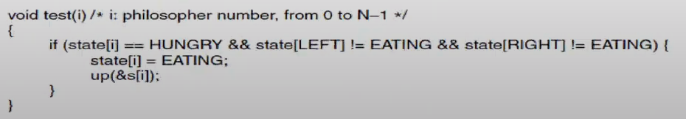

If my left and right are not eating and I am hungry, then I eat. Then I up my semaphore. It became 1.

After getting out from the critical region in take_forks function, I down my semaphore. So I can continue.

If my left or right is eating, then I will be blocked at the end of the take_forks function. I will wait until my s[i] semaphore is incremented.

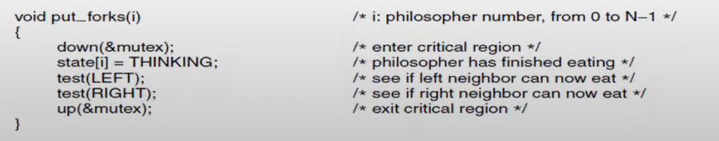

I CAN BE BLOCKED AT down FUNCTION.

I am not eating anymore, my state become THINKING.

I test my left and right.

test(LEFT) 🡪 If my left is hungry, if its left and right are not eating, then my left should be eating and I will up its semaphore.

test(RIGHT) 🡪 Do the same thing.

Assume we have this:





We have 5 philosophers and 6 forks.



Is original nonsolution valid for this?

* All of them will be able to take fork number i.
* P5 can take also the fork 6. P5 will eat and continue.
* Once P5 is done, P4 will take it.
* Once P4 is done, P3 will take it.
* Then P2, then P1.

This is not a deadlock but it is bad because even though 3 of them can eat at the same time, only one of them can eat it from time to time. This is problem of not efficient resource utilization.

Our last solution can be applied.

The Readers and Writers Problem (classical problem about inter-process communication)

I have a database (DB) and I have reader processes RP1, RP2, RP3, …, RPN.

All of the processes can read same DB at the same time.

If I have writer processes WP1, WP2, …, WPM.

Only 1 process can write to same DB at the same time. You cannot write to the same database using 2 different processes bc that would cause some data inconsistency.

So come up with some kind of inter-process communication mechanism that will let any number of reader processes on DB or just single writer process. Either many readers or just a single writer. This is reader writer problem.

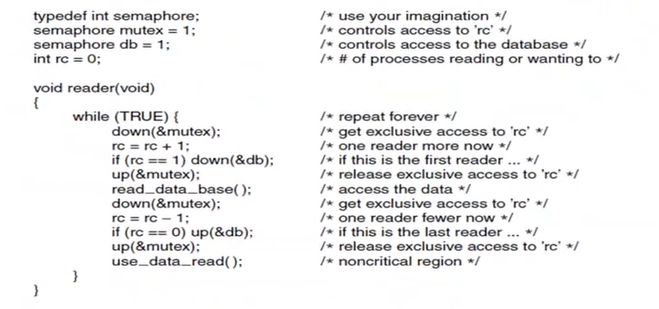



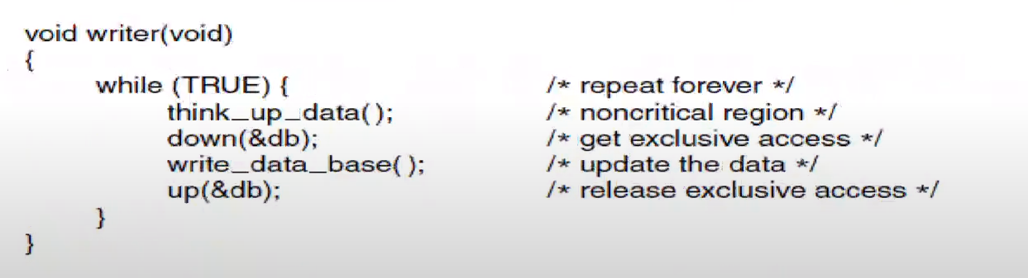

*A solution to the readers and writers problem*

*rc: reader count*

If I have the lock as writer, no other reader or writer can have the lock.

If there are many readers, I can read too as a reader.

If there is a writer, I cannot continue as a reader.

We have 2 critical regions in reader function.

if (rc==1) means that previously nobody was reading, I am the first reader. So I am trying to get the lock for the db.

Since I get the db, I can read data.

If rc is bigger than 1, then I don’t down the db bc I already got is a reader. 2nd, 3rd, 4th … readers will not try to get the database lock bc one of the readers got the lock anyway.

If rc becomes 0 after I read, I release the db lock.

This will let as many readers as possible into the database. As long as the first one gets the lock, then I am fine. If first one gets the lock, writer has to wait bc writer cannot get the lock (down(&db);). If writer has the lock, first reader cannot get in.

Only last reader will release the db lock.

This doesn’t cause any race conditions and deadlocks but if there are too many readers doing the reading all the time, writers may starve bc once the reader start reading, one of them will read and it will release the lock, other one will read and release the lock, but if there is always some reader reading the database, writer will never get the lock.